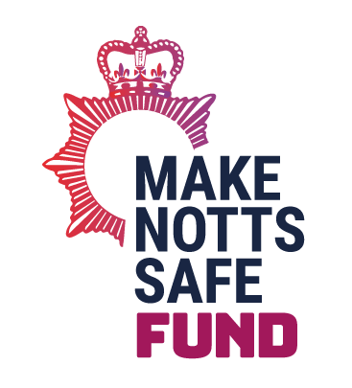
Make Notts Safe Thematic Grant
Delivery Plan

A separate delivery plan should be completed for each financial year (although we do appreciate that some elements will run across all financial years). The delivery plan provided for the 2023/24 financial year should be as detailed as possible including SMART targets and realistic timeframes. The delivery plans for any subsequent financial years needs to include a basic outline plan. There will then be a requirement to complete subsequent financial years delivery plans in more detail during the fourth quarter of each financial year.
In relation to the outputs and outcomes we are expecting applicants to detail some initial outline outputs and outcomes. If the application is then successful at Stage 1, the OPCC will work with you to further develop and define these outputs and outcomes into a theory of change.
All successful applicants will be expected to report back on progress against the final version of the delivery plan agreed during stage 2.
Project Name:
2023/24 (April 2023 to March 2024)
Task | Responsibility (by whom)? | Target date | Output/ deliverable | Expected Outcome

2024/25 (April 2024 to March 2025)
Task | Responsibility (by whom)? | Target date | Output/ deliverable | Expected Outcome

