For Consideration
Public/Non Public* | Public
Report to: | Audit and Scrutiny
Date of Meeting: | 29 April 2022
Report of: | Commissioner Henry (PCC)
Report Author: | Dan Howitt
E-mail: | ExecutiveSupport@notts.police.uk
Other Contacts: | None
Agenda Item: | 10

POLICE AND CRIME COMMISSIONER’S UPDATE REPORTS

PURPOSE OF THE REPORT

This report was presented to the Police and Crime Panel on 28 March 2022 with an overview of the progress made by the Police and Crime Commissioner’s (Commissioner) and her office in delivering against the ‘Make Notts Safe’ Plan 2021 to 2025 and fulfilling their statutory duties during the January to March 2022 period.

Supplementary papers include the latest Performance and Insight report (Appendix A) and a summary of key OPCC and force decisions made over the latest planning period (Appendix D).

RECOMMENDATIONS

The Police and Crime Panel was invited to scrutinise the contents of these reports and briefings and seek assurance on any specific areas of concern. The Panel is also invited to request further information where required and make relevant observations and recommendations within the scope of their role.

The Police and Crime Panel has a statutory duty to scrutinise performance and delivery against the ambitions of the Police and Crime Plan and of the Commissioner in fulfilling her statutory duties (Section 14 of the Policing Protocol 2011). These reports are designed to assist the Police and Crime Panel in fulfilling these responsibilities.

Preventing Crime and Protecting People From Harm

There are clear indications that our priority focus on prevention and early intervention is delivering results, particularly in reducing the risk of serious crime and protecting vulnerable people from harm in Nottinghamshire.

The OPCC, police and partner agencies continue to roll out the Safer Streets programme across targeted neighbourhoods in Newark, Nottingham, Mansfield, Sutton-in-Ashfield and Worksop South. Over £2m dedicated Home Office funding has been secured to support this work in 2021/22, with a further £134,000 of local partnership funding having been made available to sustain the successful Safer Streets project in Newark. Residents continue to benefit from free home security devices and work to trial a mobile safety app designed to improve safety and feelings of safety among women and girls. This additional funding has also enabled the police and partners to enhance Automatic Number Plate Recognition (ANPR) capabilities across the area.

Together, the Safer Streets programme, the force’s dedicated police Burglary and Robbery Teams and the multi-agency Integrated Offender Programme are helping to maintain significant reductions in neighbourhood crimes (-16%, -1,905) across Nottinghamshire. This includes reductions in residential burglary (-22%, -935), vehicle crime (-11%, -652) and robbery (10%, -79). The proportion of respondents to the Police and Crime Survey reporting experience of neighbourhood crime has also fell to the lowest level ever recorded in Nottinghamshire (4.9%) over the last year.

Further rounds of government Safer Streets funding have been confirmed through to 2024/25, with the government Spending Review allocating £50m per year over the next three financial years. This will see a focus on reducing neighbourhood crimes, anti-social behaviour and violence against women and girls. Nottinghamshire OPCC will work with local partners to secure matched funding as part of two 18 month bidding rounds scheduled over the police and crime plan period.

The Strategic Violence Reduction Board convened a planning workshop on 17 February 2022 Unit which provided an opportunity to revisit the shared partnership ambitions of the Board and consider findings and recommendations from third annual Strategic Needs Assessment for serious violence. The assessment considers the changing profile of serious violence in the context of the Coronavirus pandemic and highlights emerging issues in relation to: the spate of spiking incidents in the Night Time Economy recorded during the October to December 2021 period; rising financial pressures and the cost of living and; young people and social media.

The Violence Reduction Unit (VRU) has continued to develop and embed a local youth work strategy for Nottinghamshire. The VRU has also been working with the OPCC to establish an interim youth justice-led diversion model (Divert Plus) in custody suites in the City and County since December 2021, following the successful award of £1.5m funding earlier in the year. Divert Plus is on track to be fully implemented by April 2022. In January 2022, the VRU and OPCC announced a new thematic round of Make Notts Safe Grants, with £270,000 being made available between May 2022 and March 2025 to support third sector organisations in delivering youth diversion projects.

In terms of performance outcomes, levels of police recorded violent knife crime increased marginally in the year to December 2021 (+3%, +25), following a rise in the latest quarter. Similarly, the number of first time entrants into the youth justice system increased marginally in both the City (+9%, +10) and County (+13%, +13), but at 240, remain below the pre-pandemic baseline (263) and annual milestone ambition of <256. Average rates of homicide have fallen by 25% over the last year, with 2021 showing the lowest level ever recorded in Nottinghamshire and one of the lowest rates of homicide per 100,000 population in England and Wales.

The Performance and Insight report also shows significant improvements in pro-active preventative and safeguarding activity linked to domestic and sexual abuse over the last year. This includes a rise in the use of Domestic Violence Protection Orders (+108%, +91) and Notices (+112%, +100) and a 35% (+99) increase in disclosures as part of the Domestic Violence Disclosure Scheme (Claire’s Law). Reported domestic abuse crimes have risen by 5% during the year in line with the Commissioner’s ambition for greater reporting. The average number of domestic homicides per year, meanwhile, have fallen by 43%.

The Commissioner launched the ‘A-Z of Consent’ campaign on 10 March 2022 to help improve the safety of women and girls in Nottingham. The campaign was developed by the Consent Coalition and features key facts profiled on the City’s bus and tram network relating to a range of consent-based themes. On 15 March, the Commissioner, Consent Coalition and Nottingham Business Improvement District (BID) launched the Safe Space Pledge which sets out eight commitments that venues can take to improve the safety of women and girls. The pledge was co-designed by specialists in the domestic and sexual abuse sector and sends a clear message that the safety of all women and girls is a shared priority.

Responding Efficiently and Effectively to Community Needs

The force is maintaining strong performance in terms of call handling, response, deployable officers and investment in local policing. Further work is underway to enhance Nottinghamshire’s digital capabilities in view of the ongoing rise in online fraud and cyber-related offending.

The Commissioner and OPCC have continued to scrutinise force performance in responding efficiently and effectively to community needs throughout 2021. This included a review of the 2021 HMICFRS Value for Money Profiles published January 2021 which showed Nottinghamshire to have one of the highest levels of spending on the front line as a proportion of all force spend, and significantly higher levels of spending on local policing than the most similar force and all force average. The Commissioner is exploring a range of other outliers identified via the profiles as part of her regular meetings with the Chief Constable with a view to ensuring that the force continues to deliver effective and efficient services and best value for money for Nottinghamshire residents.

The Performance and Insight Report shows that Nottinghamshire Police continue to maintain strong and improving performance with regard to call handling and response. Abandonment rates for the 999 and 101 services fell to 0.2% and 1.2% respectively during 2021. Between 73% and 79% of all Grade 1 incidents are within the target time across both urban and rural areas. The proportion of respondents to the Police and Crime Survey stating that they have confidence in the police remains higher than the March 2020 baseline (55.4%) and annual milestone ambition (57.4%), despite a reduction seen in the latest quarter.

Levels of reported online fraud have continued to increase since March 2020, with a 27% (+782) increase recorded by police in the latest year. More than a fifth (21.3%) of respondents to the Police and Crime Survey reported having experienced fraud or attempted fraud over the last year, with the number of crimes involving loss estimated to have increased by 27% to around 64,000 offences per year. The Commissioner has made £300,000 of new funding available to improve local responses to crimes committed or facilitated online and has committed to exploring and promoting practical crime prevention tools and materials that will help better protect residents and businesses from fraud.

The Commissioner’s 2021/22 Police and Crime Delivery Plan sets out a range of measures to improve the police and partnership response to rural crime – all of which are on track to be completed by 31 March 2022. These include: additional training for police to improve understanding and responses to the issues affecting rural communities (Continual Professional Development); training for 5 Single Points of Contact within the control room to improve service response to rural crime; establishing a regular regional intelligence meeting to improve the sharing of cross-border information relating to rural crime and; introducing a bespoke Rural Neighbourhood Alert program to improve community engagement.

Supporting Victims, Survivors, Witnesses and Communities

The OPCC continues to drive improvements in services and outcomes for victims of crime in Nottinghamshire, with specific work is underway to review and recommission the Victim CARE service, improve the identification of ‘hidden harm’ and strengthen the response to hate crime.

The OPCC-commissioned strategic needs assessment for victim support and restorative justice is now fully underway. Findings and recommendations will be reported in the spring 2022 and used to help shape the commissioning of future victim support services across Nottinghamshire. Cope and recover outcomes across OPCC commissioned services have been affected by the Coronavirus pandemic, with some providers reporting increased levels of anxiety and complexity among presenting service users. Support in this area has been bolstered by the provision of additional Ministry of Justice funding for domestic and sexual abuse services over the last year in wake of the COVID pandemic.

The Performance and Insight report highlights sustained improvements in compliance with the Victims’ Code of Practice over the last year (up from 92.9% to 95.6%), providing assurance that the care needs of victims are being routinely considered and that victims are being offered support and referral to available victim service providers. Overall victim satisfaction, as monitored via the PCC’s Police and Crime Survey, also remains strong (56.2%) and continues to exceed the annual milestone improvement ambition of >53.9% for 2021/22.

Despite this, satisfaction rates among victims of hate crime have deteriorated by 3.7% points over the last year, largely due to reductions in satisfaction with ‘actions taken’ (down from 78.3% to 74.9%) and being ‘kept informed’ (down from 72.1% to 67.7%). Work is underway to address this deterioration, with a focus on ensuring that the provision of updates and follow up is in line with the needs and expectations of victims.

Levels of hidden harm police recorded ‘hidden harm’ have fluctuated throughout the year, with rises in identified Child Sexual Exploitation crimes (+5%, +22) and ‘Honour’ Based Violence (+14%, +8). Police recorded Child Criminal Exploitation (-15%, -11) and modern slavery (-7%, -9) referrals, however, saw minor reductions in 2021. In January 2022, the OPCC launched a new thematic round of Make Notts Safe Grants, making £330,000 available to local third sector organisations to help improve the identification and response to hidden harm between May 2022 and March 2025.

The Commissioner’s Police and Crime Survey has identified significant and sustained deterioration in the proportion of respondents feeling safe when outside in their area after dark over the last year, falling from 63.1% to 56.8%.

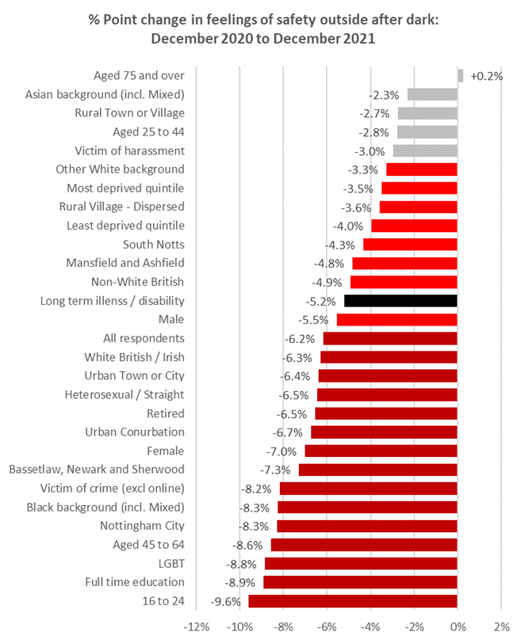

Subsequent analysis has identified that:-

Reductions in feelings of safety have been reflected across almost all demographic and geographic groups. This indicates that a broad range of factors are likely to have influenced this trend – some of which may be beyond the immediate control of key stakeholders
- The most significant reductions in feelings of safety have been seen with regard to young people aged 16 to 24 and those in full time education, the LGBTQ+ community, people aged 45 to 64, Nottingham City residents, people from Black / Black British backgrounds and victims of traditional crime.
- Groups least likely to feel safe when outside in their area after dark include: young people aged 16 to 24, students, people that have experienced some form of harassment in the last year, the LGBTQ+ community, people with a long term illness or disability, residents living in the 20% most deprived neighbourhoods and females.

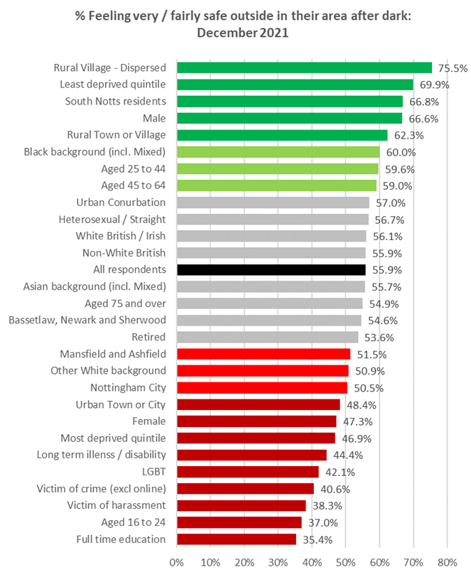

Priority cohorts with the lowest feelings of safety and showing the greatest reduction in feelings of safety over the last year include: young people aged 16 to 24, students, the LGBTQ+ community, females and victims of crime.

No national benchmarking is currently available for this indicator due to temporary changes in the methodology for the Crime Survey for England and Wales in 2020 as a result of the Coronavirus Restrictions in place.

Factors likely to have impacted upon local feelings of safety during this period include: the high profile murder Sarah Everard in March 2021 and subsequent sentencing of Wayne Couzens in June and July 2021; the impact of Coronavirus restrictions on lifestyles, behaviours and perceptions; changes in local crime trends and the high profile rise in ‘spiking’ reports recorded between October and December 2021.

The Commissioner is working with local partners to address and mitigate the impact of this emerging trend via a range of activities and initiatives, which include:

A programme of work delivered via the £293,542 Safety of Women at Night (SWaN) fund which will see training for Night time economy staff on Violence Against Women and Girls, campaign activity, the provision of Safe Spaces for women, improving safety on Nottingham’s tram network and developing night time economy VAWG pledge and accreditation scheme for venues

£400,000 investment from the Late Night Levy to review safety in the night time economy. A Night Time Economy needs assessment is currently underway and due to report later in the year

Targeted work in Ashfield as part of the Safer Streets Programme which will see the introduction of a Safer Spaces Accreditation Scheme and work to trial and roll out the StreetSafe mobile app trial to help improve safety of women and girls

Exploring opportunities for more targeted pro-active media and communications, particularly among the priority cohorts identified – including students, LGBTQ+ community, disability groups and victims of harassment and other crimes.

Organisational Developments

The OPCC has developed a comprehensive delivery plan for 2021/22 which is being used to track a range of actions that support and underpin the statutory police and crime plan published in January 2021. The delivery plan will be made available to members of the Police and Crime Panel to inform their scrutiny programme and formally published later this year to inform the Commissioner’s Annual Reporting process.

The Commissioner launched her programme of Make Notts Safe Grants on 26 January 2022 as part of her pledge to make £1m available to empower third sector providers to support delivery of the Make Notts Safe Plan. For the first multi-year grant funding will be made available via rounds of thematic grants, Community Chest Grants and Innovation Fund grants. Thematic grants include the aforementioned areas of youth diversion (£270,000) and ‘Hidden Harm’ (£330,000), in addition to upcoming bidding opportunities for activity to tackle hate crime (£100,000), rural crime (£100,000) and improve community involvement (£100,000).

The Commissioner attended the formal handover of the new Nottinghamshire Police and Nottinghamshire Fire and Rescue Services’ joint headquarters on 20 January 2022. New facilities at the site, including shared office space and a new police-control room, are expected to drive efficiencies and improve ways of working across both organisations. Commissioner Henry stated: “Our HQ is the newest tool in our arsenal as we combat crime across the county and will enable us to deliver 21st Century policing in Nottinghamshire. The unveiling of our new headquarters is also a testament to our partnership working with the fire service, enabling us to better serve the public and save money.” The Office of the Police and Crime Commissioner and staff from Nottinghamshire Police and Fire and Rescue Service will relocate within Headquarters during early 2022.

National Developments

The government’s Levelling Up White Paper was published on 2 February 2022 setting out a plan to transform the UK by spreading opportunity and prosperity to all parts of it. Among the twelve national levelling up missions are plans to restore a sense of community, local pride and belonging, especially in places where they have been lost. The paper sets an ambition to reduce homicide, serious violence and neighbourhood crime by 2030, with a focus on the worst affected areas (Mission Eleven).

This includes investment of £50m from the Safer Streets Fund every year of the 2021 Spending Review period to give Police and Crime Commissioners and local authorities the resources they need to tackle crime and anti-social behaviour. The government has committed to ‘clamping down on the factors that damage people’s pride in their area’ and set an expectation that ‘people will give back to their communities when they are found to have broken the law’. The government has also committed to working with partners across the youth justice system to ensure increase the use of community payback for 16 and 17 year olds who commit crime. The Commissioner will continue to support the delivery of the government’s objectives in these areas in line with the ambitions of the Levelling Up agenda, government Beating Crime Plan and the Make Notts Safe Plan

The Home Secretary announced findings from part two of the review into the role of PCCs on 7 March 2022, which included a series of recommendations designed to strengthen the ‘and crime’ element of the PCC role. The recommendations and local implications of the review are explored in a standalone paper to the panel.

Decisions

The Commissioner has the sole legal authority to make a decision as the result of a discussion or based on information provided to her by the public, partner organisations, Members of staff from the Nottinghamshire Office of the Police and Crime Commissioner (NOPCC) or Chief Constable. The Commissioner’s web site provides details of all significant public interest decisions.

  - Panel Members have previously requested that the Commissioner provide a list of all forthcoming decisions (Forward Plan) rather than those already made. This Forward Plan of Key Decisions for the OPCC and the Force has been updated and is shown at Appendix B.

Human Resources Implications

None - this is an information report.

Equality Implications

The Commissioner’s decisions and strategic direction are fully compliant with the Equality Act 2020

Risk Management

There are no significant risks within this report that would need to be drawn to the attention of the Police and Crime Panel.

Policy Implications and links to the Police and Crime Plan Priorities

This report provides Members with an update on performance in respect of the Make Notts Safe Plan, and provides information on emerging issues relating to fear and perceptions of crime, the Government’s ‘Levelling Up’ agenda and outcomes of the second stage of the Home Office Review of the PCC role.

Changes in Legislation or other Legal Considerations

The Commissioner undertakes routine horizon scanning of emerging legislation, government publications, audits and inspections and significant consultations, statistics and research findings in order to help inform local strategic planning and decision making.

The Elected Local Policing Bodies (Specified Information) (Amendment) Order 2021 came into force on 31 May 2021 requiring Police and Crime Commissioners to publish on their websites:

A statement on how their force is performing in relation to key national priorities for policing;

Copies of HMICFRS PEEL inspection reports, and a summary assessment of the force’s performance; and

Copies of IOPC data on force complaints, and a statement on how the PCC (or Mayor’s Office) is exercising its complaints-handling functions under the Police Reform Act 2002.

The Commissioner has taken steps to ensure compliance with the amended legislation and will be publishing a statement on how the force is performing in relation to the national police outcomes framework when publishing her statutory Police and Crime Plan.

Details of outcome of consultation

The Chief Constable has been sent a copy of this report.

Appendices
- Nottinghamshire Revised Performance and Insight report to December 2021
- Forward Plan of Key Decisions for the OPCC and the Force to February 2022

Background Papers (relevant for Police and Crime Panel Only)
Make Notts Safe Plan 2021 - 2025

For any enquiries about this report please contact:

Sharon Caddell, Chief Executive and Monitoring Officer of the Nottinghamshire Office of the Police and Crime Commissioner, ExecutiveSupport@notts.police.uk, Tel: 0115 8445998

Dan Howitt, Head of Strategy and Assurance of the Nottinghamshire Office of the Police and Crime Commissioner, ExecutiveSupport@notts.police.uk, Tel: 0115 8445998

Section 13 of the Police Reform and Social Responsibility (PR&SR) Act 2011 requires the Commissioner to, subject to certain restrictions, provide the Panel with any information which they may reasonably require in order to carry out their functions, and any other information which the Commissioner considers appropriate
Police and Crime Panels: A Guide to Scrutiny, Local Government Association (Updated 2016)
Police Reform and Social Responsibility Act 2011
Initial reductions seen during 2020 were largely impacted by changes in lifestyles and reductions in criminal opportunity as a consequence of the Coronavirus restrictions in place
Government’s ‘Levelling Up’ Paper, 2 February 2022
Based on 3 year rolling average on account of the low volume of offences recorded
HMICFRS Value for Money Profiles 2021, Published 21 January 2022
Comprising low volume high harm offence categories such as child sexual exploitation, child criminal exploitation, modern slavery, forced marriage, ‘honour based violence and Female Genital Mutilation (FGM)’
Levelling Up the United Kingdom, Government Policy Paper, 2 February 2022
Update on Part Two of the Police and Crime Commissioner Review, Written Ministerial Statement, 7 March 2022
http://www.nottinghamshire.pcc.police.uk/Public-Information/Decisions/Decisions.aspx

