For Information
Public
Report to: | Joint Audit and Scrutiny Panel
Date of Meeting: | 19th April 2022
Report of: | Deputy Chief Constable Barber
Report Author: | Detective Inspector Claire Gould
E-mail: | Claire.gould@notts.pnn.police.uk
Other Contacts:
Agenda Item: | 11
*If Non Public, please state under which category number from the guidance in the space provided.

Complaint and Misconduct Investigations

- Purpose of the Report

1.1 To inform the Joint Audit and Scrutiny Panel (JASP) that reform to the police complaints and misconduct legislation commenced on 1st February 2020. The data supplied within this report is from 10th November 2021 to the 11th March 2022.

1.2 To provide a final report, using data under the former legislation, of how the force compared nationally when dealing with complaints and misconduct matters.

- Recommendations

2.1 It is recommended that the title/purpose of this report be revised by the Head of Professional Standards Directorate (PSD) and the OPCC Chief Executive to ensure scrutiny is provided to those key aspects of the complaints and misconduct system implemented by the 2020 legislation.

- Reasons for Recommendations
3.1 To ensure that the JASP ensures the force and OPCC are compliant in their duty to record and investigate complaints and misconduct matters in accordance with the:
- Police (Conduct) Regulations 2020
- Police and Complaint and Misconduct Regulations 2020
- Independent Office for Police Conduct (IOPC) Statutory Guidance 2020
- Summary of Key Points

4.1 The IOPC have not released their performance data for the last two quarters since the last JASP report (November 2021). The most recent findings are therefore detailed below. It important to note our position nationally in how we finalise complaints.

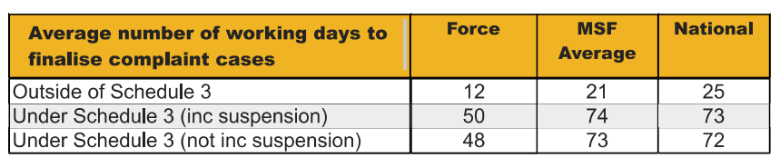

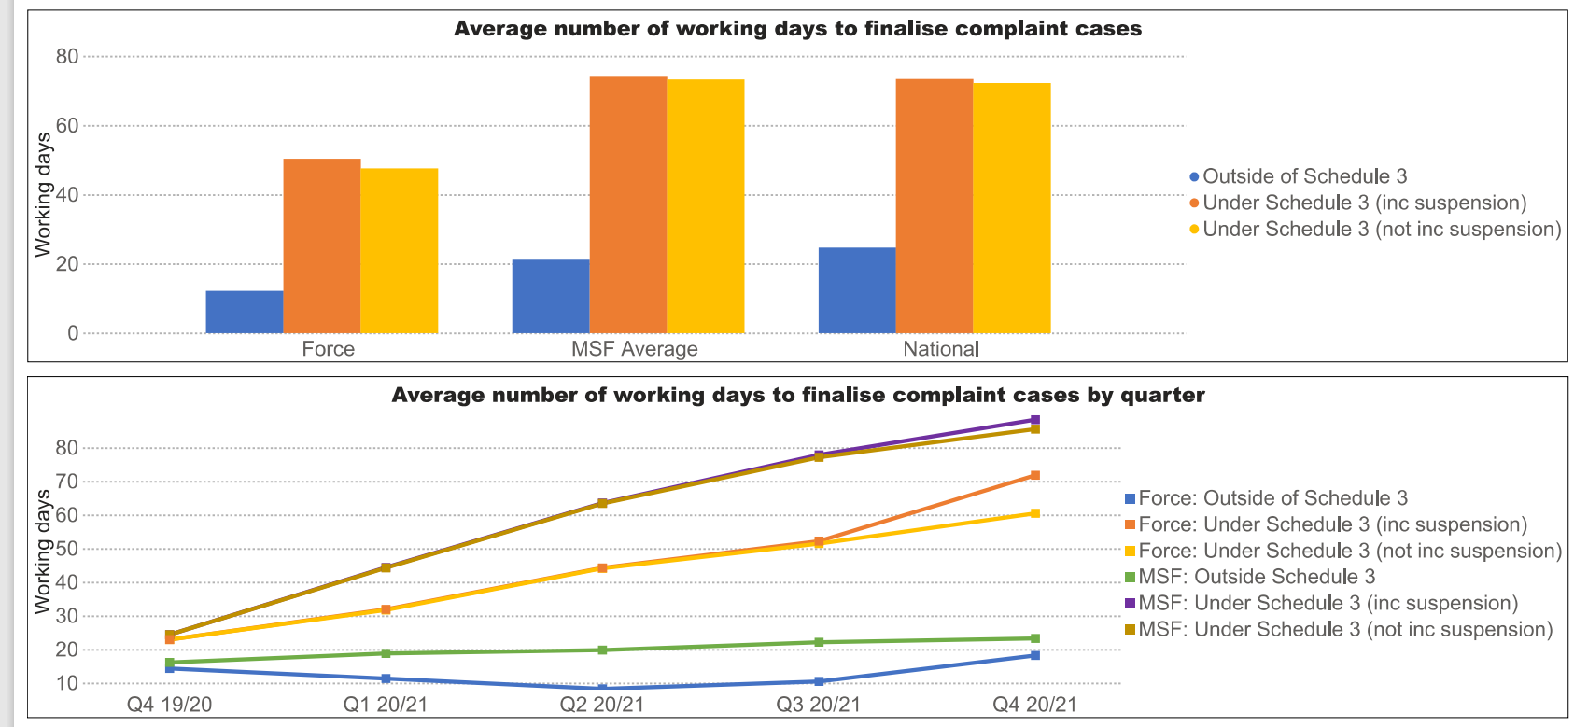

From these figures Nottinghamshire Police are outperforming MSFs and the National Average in relation to all areas of complaint handling.

Despite an increase in complaint reporting, we have improved our timeliness in regards to the time taken to record complaints. The rise in complaints was anticipated owing to the relaxing of restrictions in relation to Covid-19 and hence returning more towards business as usual.

Despite no data from the IOPC the Business objects data demonstrates that we have finalised more cases last year (1162) compared to 2020 to 2021 (1072). Our timeliness in terms of time taken to resolve complaints outside of schedule 3 remains a key priority. This was 44 days in the previous reporting period. Despite increasing to 67 days in December 2021 this is on track to be under 40 days by April 2022. These delays were attributed to retirements and movements of staff within the RPH department.

4.2 The new Police Regulations 2020 raised the bar for Misconduct. It looked to embed a culture of learning amongst officers and staff and to ensure that disciplinary proceedings are used only for serious misconduct and criminality.
This has been successfully embedded within Nottinghamshire Police, especially in relation to the use of Practice Requiring Improvement. Feedback has been obtained from managers delivering PRI who have been very positive about the use of PRI and how it has been received by those participating in the process,

In 2021 this was added to the Staff Misconduct Policy and Police Staff are now eligible for PRI where appropriate.

To date 92 officers and staff have undergone the Reflective Practice Review Process (RPRP) under Practice Requiring Improvement (PRI). Common themes include incivility and rudeness, general levels of service in

4.3 Initial complaint handling:

- In the previous reporting period, the number of complaints received by the force was 330 in total. This reporting period has seen a total of 333 complaints, again this was anticipated following the easing of restrictions to the public.

- It is clear that a quick and professional conversation early is pivotal in resolving dissatisfaction with the service. Early engagement with the public is managed by a DS in the Complaints and Misconduct Unit who oversees 4 Complaints Support Officers and two members of Admin staff. These ensure that efforts are made to contact complainants at the earliest opportunity in order to attempt service recovery and resolve as many complaints as possible to the satisfaction of the complainant. Where this is successful the matter is logged Outside of Schedule 3 of the Police Reform Act. No further action is therefore required.

- Where matters are more complex or if the CSOs have not been able to resolve a complaint to the satisfaction of the person lodging the complaint then this is recorded inside of schedule 3 and is then dealt with by means of Reasonable and Proportionate Handling (RPH) or internal PSD investigation (This is determined by indications of potential criminality or misconduct).

Inside Schedule 3 Complaints | Outside Schedule 3 Complaints
158 | 175

The above shows an average of 52.5% of complaints are dealt with outside of Schedule 3. These are reviewed by a supervisor to ensure consistency and the correct application of the regulations.

  - Staff skills and knowledge-

There are now three Reasonable Proportionate Handler (RPH) Sergeants within the PSD. After a retirement in Dec with a DS leaving we had two temporary sergeants replace them. It is a difficult arena to learn with the regulations and learning the craft of complaint handling. They are now settled and adept at their role. Timeliness has risen in relation to RPH and PSD investigations has risen in the last 12 months, however there are recent improvements in RPH timeliness in recent months.
The CMU has had a change of DS in the ‘front end’ function which handles the initial handling of complaints. This has the same knock on effect with the time needed to gain a sound understanding of the regulations and requirements with that role.

During the last reporting period three new DCs have joined the CMU – they too have received the necessary external and internal training require to perform the role of a DC within the CMU. Three experienced investigating officers have also retired/ resigned. We have successfully recruited into these roles (with one due to started at the end of March 2022). Again this adds to the inexperience within the department and need to train up staff and build knowledge and expertise. They all have dedicated tutors and will be guided through the PIP1 process. Ch Supt Lawton also introduced the option for IOs to complete the PIP2 process for IOs in the department (as well as for DCs). This is in its early stages but again all will be provided the necessary support required and will upskill the department.

  - Organisational learning-

This is a key area for PSD. The emphasis will be on learning. The meetings and hearing officer is responsible for collating organisational learning. There is learning from all matters dealt with at meetings and hearings and as such it is now captured and dealt with appropriately to maximise all opportunities for learning.

A quarterly PSD bulletin is underway. It will share appropriate cases and the learning identified. The staff associations and Police Federation have all been consulted and have agreed this. This will ensure officers/staff do not make mistakes that could have been avoided.

January 2022 was focused on Sexual Harassment in the workplace. A sexual harassment survey was conducted with all officers and staff. 400 took part. The results will be shared force wide with opportunities to join focus groups on dealing with SH going forwards.

PRI remains a key focus of the PSD with the full backing of the IOPC and OPCC.

  - Inter Departmental links-

HR are now intrinsically linked into PSD. A monthly meeting is held to ensure HR are aware of individuals. There are multiple benefits to this including support for the officer/staff member and the investigation. Student officers from Operation Uplift continue to come to the attention of PSD. DCI Sanders meets with the Police Federation to discuss this and identify and trends and or patterns in an attempt to try and prevent

  - Reflective Practice-

Home Office Guidance states ‘PRI means underperformance or conduct not amounting to Gross Misconduct or Misconduct, which falls short of the expectations of the public and the police service as set out in the Code Of Ethics’.

The purpose behind the reformed system is to develop an approach to the handling of matters which fall short of the expectations set out in the Code of Ethics and are considered low-level conduct and mistakes.

To date 92 officers and staff have been referred to the Reflective Practice Referral Process (RPRP) under Practice Requiring Improvement. During the reporting period we have had 17 officers and staff subject to PRI. Nottinghamshire continue to lead the way in the use of PRI.

4.4 The following areas of organisational level learning have been addressed in the reporting period:

  - A review of Body Worn Video. All officers have been reminded about the activation of BWV whilst at domestic incidents.
  - Off duty conduct issues have risen in the last six months several of which have resulted in PRI.
  - Incivility and rudeness has also accounted for 8 PRI matters. This remains a key area of all complaints to the PSD.

4.5 A comparison of performance data was taken from 11th November 2021 to 11th March 2022 in comparison to the same period last year. The headlines are documented below:

• Complaint cases recorded are up 25.2%. An increase of 83 cases.
• Conduct cases recorded have reduced slightly from 44 to 37 for the same reporting period last year.
• Regulation notices have reduced by -15.2% A decrease of 5%. Similar reporting levels to the previous reporting period.
• Local investigations (RPH) have shown an improvement in the average number of days to finalise. Previously 59.3 days it is now at 48.7 days. The existing four legacy cases have been removed from this calculation and are being monitored separately.
• The average number of working days to complete a conduct case has risen by 42.9%. From 58.0 days to 82.8 days. This is a result of the drop in staffing levels from retirements and resignations coupled with an inexperienced CMU. These will be monitored going forwards and it is expected that timeliness will improve going forwards.

.

- Financial Implications and Budget Provision

5.1 There are no financial implications arising from this report.

- Human Resources Implications

6.1 PSD continues to be an exceptionally busy area of policing. Additional staff in the form of two further Constables have been approved at the 2021 ADA and are to be appointed.

- Equality Implications

7.1 Equality data is recorded in relation to recording, compliance and monitoring of complaints and misconduct matters. The Head of professional Standards provides a quarterly report to the Equality Diversity and Human Rights Board chaired by the Chief Constable.

- Risk Management

8.1 Any risks associated with the recording and compliance of complaints and misconduct are reported on an exception basis to the Force Organisational, Risk, and Learning Board chaired by the Deputy Chief Constable.

- Policy Implications and links to the Police and Crime Plan Priorities

9.1 The recording and monitoring of complaints and misconduct matters is linked with the Police and Crime Plan Priority, Transforming Services and Delivering Quality Policing.

- Changes in Legislation or other Legal Considerations

10.1 There are no changes in legislation in relation to this report.

- Details of outcome of consultation

11.1 There has been no consultation in relation to this report as it is an update for the JASP.

12. Appendices

12.1 None

