For Information
Public | Public
Report to: | Audit and Scrutiny Panel
Date of Meeting: | 28 July 2022
Report of: | Deputy Chief Constable
Report Author: | N Kamionko – Information Management Lead
E-mail: | Nicky.kamionko@notts.police.uk
Other Contacts: | Lucy.greaves@notts.police.uk
Agenda Item: | 10

Nottinghamshire Police Information Management - Freedom of Information and Data Protection Information Requests update for May 2021 to May 2022.

- Purpose of the Report

  - To provide the Audit and Scrutiny Panel with data on the legislative compliance for Information Requests under the Freedom of Information Act and Data Protection Act legislation for May 2021 to May 2022.

- Recommendations

  - For Members to note the monitoring statistics for this period in relation to information requests processed by Nottinghamshire Police in line with Freedom of Information and Data Protection legislation.

- Reasons for Recommendations

3.1 To enable the Audit and Scrutiny Panel to fulfil its scrutiny obligations to oversee and consider Freedom of Information and Data Protection Subject Access Request (SAR) Compliance.

- Summary of Key Points

4.1 Nottinghamshire Police as a public authority has a legal responsibility to respond to information requests received and processed in line with Freedom of Information Act (FOIA) and Data Protection legislation. These requests are processed and completed by the Information Request Team.
4.2 The legislative deadlines for the Acts are:-
- Freedom of Information 20 working days
- Data Protection Subject Access 1 calendar month from receipt of request

4.3 Table 1 – FOI Completion Figures from May 2021 to May 2022.
The Force monitors compliance and provides quarterly statistics for Freedom of Information to the NPCC Central Referral Unit based in Hampshire. Since September 2019 compliance figures in respect of FOI and Subject Access requests have been provided to the Information Commissioners Office for performance monitoring purposes and are published on the ICO website.

Current Demand Levels: FOI

- We continue to have one dedicated Information Request Officer to manage all FOI requests with support from the Information Request Team Leader. This process remains under review. Compliance levels have fluctuated during this period due to single person dependency and absence relating to training and annual leave.
- We continue to work to reduce the backlog and improve compliance rates.
- The triage process initiated in November 2021 remains in place whereby all FOI requests received are subject to initial review by the Information Request Team Leader and assigned a RAG status based on the nature of the request. The RAG status of the request will dictate what level of review the response to the request undergoes. This is to ensure that key engagement with relevant subject matter experts (SME) is made in order to ensure that the information being provided is accurate and that any contextual information to assist the applicant in understanding the information is provided. It also assists the Freedom of Information Request officer in identifying any operational risks posed by disclosure which enables them to consider whether any appropriate FOI exemptions are engaged.

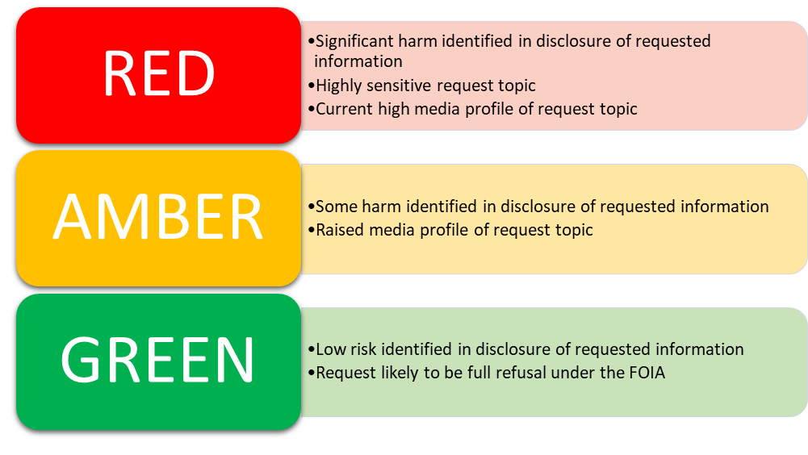

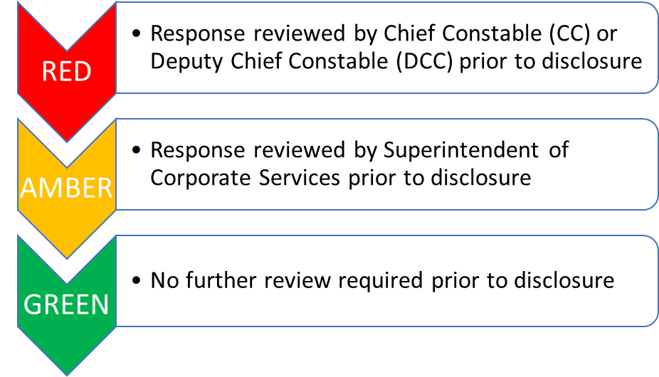

4.4 Table 2 – FOI Internal Review Completion Figures from May 2021 to May 2022.
All requestors have the right to an internal review if they are unhappy with the handling of a request for information, made under the FOIA. This could be because:
- an exemption was applied, meaning the request (or a part of it) was denied;
- the 20 working day deadline was not met;
- a full response was not provided; or
- the request was otherwise not handled correctly.
Unlike FOI requests, there is no statutory time frame for carrying out internal reviews, but we aim to provide a full response within 20 working days

Current Demand Levels: Internal Reviews
- The number of internal reviews remain small in comparison to the number of FOI requests received each month which is a good indicator that the majority of FOI requestors are satisfied with the responses they receive.
4.5 Table 3 – SAR Completion Figures from May 2022 to May 2022
The Force monitors compliance and provides quarterly statistics for Subject Access Requests to the NPCC Central Referral Unit based in Hampshire. Since September 2019 compliance figures in respect of FOI and Subject Access requests have been provided to the Information Commissioners Office for performance monitoring purposes and are published on the ICO website.

Current Demand Levels: Subject Access Request
- We continue to find that requests are becoming more complex and voluminous in nature due to increased social awareness of GDPR and right of access provisions.
- We are finding the differences in compliance levels across the year are mainly the result of standard levels of absences relating to sickness, leave & training.
- We continue to work to reduce the backlog and to increase our compliance rating.

4.6 Table 4 - Other types of Information Requests
Category | Description | Time scale
Court Orders* | Court orders which can be received from any court in the UK and Ireland for Child Care, Private and Family Proceedings. | Can be required immediately or within days due to the threat, risk & harm of the case
CCrims Checks &  Annex D’s | 2013 Protocol and Good Practice Model - Disclosure of information to Local Authorities on closed cases of alleged child abuse and linked criminal and care directions hearings into the Family Justice System. | Can be required immediately or within days due to the threat, risk & harm of the case
Insurance | Validation of details in relation to crimes for insurer to settle claim | 30 working days
Home Office | UK Border Agency and Immigration requiring confirmation and details of Police involvement for those wishing to stay in the country | 40 calendar days
Housing Confirmation | Local and Social housing requiring confirmation of the reason given by the person who has presented to them as homeless. | 10 working days
Housing General | As above but require more specific detail | 40 calendar days
Insurance Appendix E | Insurance companies requiring information in relation to a claim that they believe is fraudulent | 40 calendar days
NHS | General Medical Council, Nursing Midwifery Council require details of a registered practitioner who has been involved with the police to consider their fitness to practice | 20 working days
Legal proceedings | Private legal proceedings such a personal injury claims | 20 working days
Other Police Forces | Request from other forces for information held by Nottinghamshire Police | No set timescale as soon as is practicable
Schedule 2, Part 1, Paragraph 2: Crime and Taxation | Requests from other prosecuting bodies such as DWP, local authorities and RSPCA | 20 working days

Current Demand Levels: Court Orders - CCRIMS

The number of Court Orders received during this review period has remained high. Of particular note and which are highlighted above are the Ccrims. The processing of these requests are single person dependant currently and this is being closely monitored. Work is ongoing to explore opportunities within the wider Multi-Agency Support Hubs to reduce this backlog and meet demand. Further work is also required to understand where the demand is coming from e.g. is it predominantly Local Authority Social Care Departments. Engagement can then be made with the relevant stakeholders to explore options for managing demand differently. The majority of all Court Orders received are responded to within the order deadline as they are prioritised over other types of request due to the risk of delays on cases being managed through the Family Court system. This prioritisation can impact on the corresponding delays to the other types of request such as FOI’s and Subject Access requests.

- Financial Implications and Budget Provision

  - None.

6 Human Resources Implications

  - There are no direct HR implications for this year
7 Equality Implications

  - There are no equality implications
8 Risk Management

  - Any risks relating to the FOI/DP function are identified on the Information Management Risk Register and managed locally. The Senior Information Risk Owner (DCC Barber) monitors all relevant risks via the Information Management Board

9 Policy Implications and links to the Police and Crime Plan Priorities

  - Links to Make Notts Safe Plan: Police & Crime Plan 2021-25:
    - Responding efficiently and effectively to community needs and Supporting victims and survivors, witnesses and communities - The benefits of providing a good service to the public and our partner organisations by responding to all types of information requests fully and within an acceptable timescale will support the Commissioners pledge to improve confidence and satisfaction in policing services. It will also reduce complaints to both the Information Commissioners office and PSD and reduce the resources required to respond to this failure demand.

10 Changes in Legislation or other Legal Considerations

N/A
11 Details of outcome of consultation

11.1 No consultation took place in preparing this report

12. Appendices

12.1 None

13. Background Papers (relevant for Police and Crime Panel Only)

- No background papers have been provided.

