For Information
Public/Non Public*
Report to: | Joint Audit and Scrutiny Panel
Date of Meeting: | 10 August 2022
Report of: | Deputy Chief Constable
Report Author: | N Kamionko – Information Management Lead
E-mail: | Nicky.kamionko@nottinghamshire.pnn.police.uk
Other Contacts: | Lucy.greaves@nottinghamshire.pnn.police.uk
Agenda Item: | 11

Force Report on Monitoring, Review and Assurance of the Publication Scheme January to May 2022.

- Purpose of the Report

  - The purpose of this report is to update the Joint Audit & Scrutiny Meeting on the current Force position in relation to NPCC & ICO Publication Scheme requirements.

  - To update the Audit & Scrutiny Meeting on the plan for deploying Single Online Home (SOH), part of the NPCC Digital Public Contact programme, during 2022 which has implications for the standardisation of publicly available data linked to Publication Scheme requirements

- Recommendations

  - The Audit & Scrutiny Meeting is asked to note the contents of this paper

  - A further paper will be provided to the Audit & Scrutiny Panel in Q1 2023 providing end of year metrics relevant to SOH and the Publication Scheme compliance document at Appendix A

- Reasons for Recommendations

3.1 To provide awareness of the current position of Nottinghamshire Police in terms of the Publication Scheme requirements and the plans for deploying Single Online Home

- Summary of Key Points

  - Current Position – Use of Force Website:
- The purpose of the Publication Scheme is to let the public know what information is “readily available” from Nottinghamshire Police. By readily available we mean that the information is available on our website, can be obtained from us upon request by letter, e-mail or telephone call, can be purchased from us or can be found in another location e.g. PCC’s website or hard copy in a local library
- We aim to publish as much information as possible about our work through the scheme, except where it would not be in the public interest to do so, for example, because it might prejudice law enforcement or the health and safety of our staff, or our ability to secure best value from local policing because information is commercially sensitive.

  - We continue to publish FOI responses and monitor the Force Website traffic to inform of any areas of interest or concern and the latest website traffic figures are published below:

January – May 2022

Website area | Number of pageviews
Total pageviews | 691,740
Your area | 16,715
News | 1,067,734
Advice | 13,198
Contact | 24,273
Careers | 34,888
About | 10,747
Information | 5,769

4.3 Future position: Single Online Home (SOH)
- The vision of the NPCC Digital Public Contact (DPC) Programme is "To transform the police's relationship with the public by introducing a new channel that is as public focussed as 999." The Single Online Home (SOH) platform will offer the public a consistent, easy-lo­ use way of engaging with their local police force digitally and of accessing police services and information online wherever they are in the country. Essentially it offers a "digital front counter" as an online channel of choice for the public. Each participating police force will be able to offer a range of nationally consistent online services to the public but with their own local identity.
- The SOH platform offers improved benefits to both police forces and the public, including enhanced security and performance infrastructure, with 24/7 technical support availability, and increased online reporting.
- "Effective use of technology" is highlighted as one of the key enablers in responding efficiently and effectively to local needs in the PCC’s Make Notts Safe Plan and the delivery of SOH is consistent with the PCC's commitment within the Plan to strengthen our ability to share data and intelligence across agencies to prevent crime, support victims and target offenders, and also with the commitment to improve police contact and engagement with the public through digital channels.
- The provisional go live date is now set for Sept 2022.

  - How Single Online Home will look - Police.co.uk
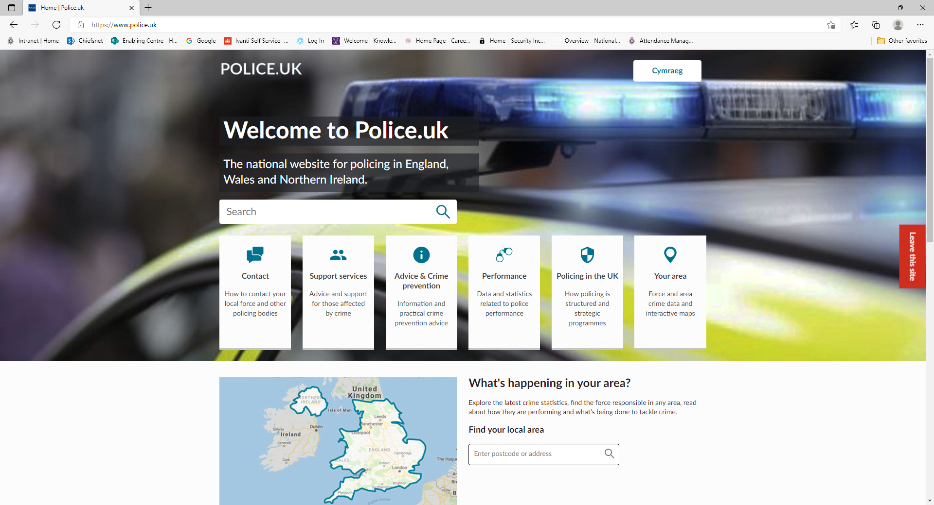
- Financial Implications and Budget Provision

5.1 None
- Human Resources Implications

6.1 None

- Equality Implications

7.1 None
- Risk Management

8.1 None

- Policy Implications and links to the Police and Crime Plan Priorities

9.1 None

- Changes in Legislation or other Legal Considerations

10.1 None

- Details of outcome of consultation

  - No consultation took place when preparing this report

12. Appendices

12.1 None.

13. Background Papers (relevant for Police and Crime Panel Only)

  - None

