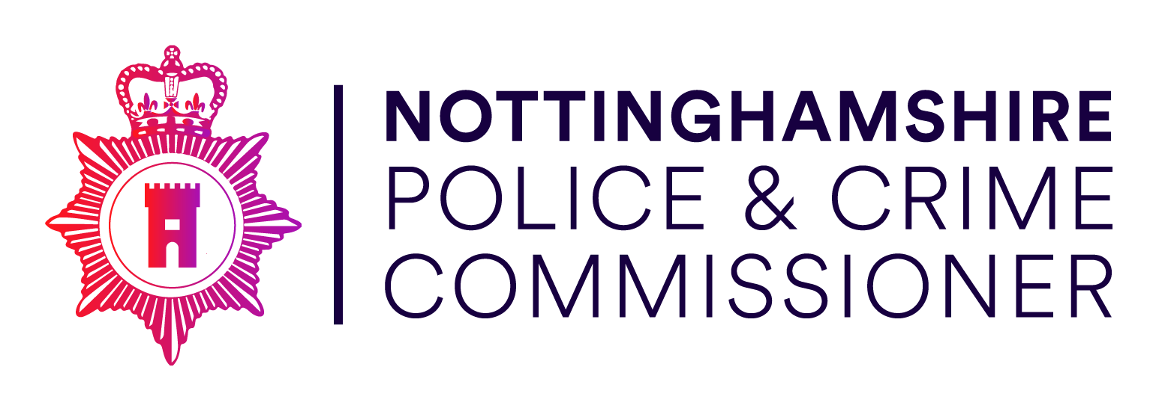

Precept 2022-23

January 2022

The Police & Crime Commissioner’s Precept 2022-23

Letter from the Minister

In announcing the Provisional Settlement figures for Police Grant the Minister has made the following comments:
- Funding nationally for Policing will increase by £769m in the form of grant for the uplift in police officer numbers and increased council tax freedoms.
- Core Police Grant will increase to reflect the number of officers recruited for Uplift.
- Precept freedoms allow for a £10 increase on Band D properties, raising
£288m nationally if all Commissioners take this up.
- Funding of the Uplift of 8,000 officers by March 2023 will continue to be provided through core grant and specific grant based on performance.
- Continued support to cover the increase in pension costs.
- Continued support for National programmes such as ESN and NLEDs.
- £100m efficiency savings across the sector.

Introduction
Considering the assumptions and opportunity made available by the Minister the Nottinghamshire Police & Crime Commissioner is proposing a precept increase of
£9.99 for the 2022-23 financial year.

This increase in the precept supports the budget report and Commissioners commitment to increase in police officer numbers in our neighborhoods. The priorities of the revised Police and Crime Plan - the ‘Make Notts Safe Plan’, are fully reflected in our spending plans and include:
- Serious violence and knife crime
- Violence against women and girls
- Neighborhood crimes, including burglary, vehicle crime robbery and rural crime
- Other high harm offences, such as slavery, exploitation, and abuse
The Commissioner also supports Victims Services through formal contracts and grants with the third sector, these are seen has having growing importance and additional funding for their activities has been provided for.
This budget supports fully the Police & Crime Plan for 2022-23.

Government Assumptions
In November the spending review announcement provided more detail than usual as to what could be expected in the December settlement. It was announced that there would be further precept freedoms of up to £10 on a Band D property for the next 3 years, along with increased certainty regarding overall grant levels. The Government intention for this was to ensure adequate resources to deliver the national uplift programme, fund employers national insurance increases and provide for a pay award.

In providing the provisional grant settlement figure in December the Government has made certain assumptions in relation to the total funding available for Policing.
Firstly, it provides additional resource to the main police grant for the Uplift of officers by 20,000. This increase is in the core police grant and is therefore likely to continue in future years, although an element is based on achieving recruitment numbers set by the Home Office (Specific Grant). The planning assumption if for an additional 8,000 officers to be recruited in 2022-23.
Secondly, the £10 precept freedom indicated is for three years ahead of the next CSR and funding formula review. The Home Office have commented that it expects any future funding gap, from inflationary pressures, to be resourced from continued precept freedoms. Further detail on what impact this will have in Nottinghamshire is provided in the Medium Term Financial Strategy.

The additional Treasury Grant for the remainder of the pensions funding gap continues for 2022-23; as does the Home Office additional grant for Pensions. The immediate costs of the McCloud pension remedy will be met by the Treasury.

Future outlook
We are in unprecedented times all of which have a major impact on the Government funding available for the public sector. It is reassuring to hear that Policing remains priority, but this is alongside the NHS, the cost and repayment in relation to COVID and the cost of BREXIT.
The Government remains committed to being able to balance the budget and reduce borrowing. But the increased borrowing for COVID against an economy that is still in a recovery period means that the repayment period for borrowing is likely to be long term.
In recent years the Home Office has relied on Police and Crime Commissioners to take advantage of Council Tax freedoms and set above inflation increases to cover some of the inflationary costs no longer provided for within the Policing Grant. However, the impact of COVID could still have impact on Council Tax collection funds.
However there is now signs of recovery and a surplus on collection is estimated for 2022-23.
The impact on the Council Tax Base, which last year saw the base increase by only 0.25%, looks also to be in recovery with this year’s increase of 1.92% more in line with the expected upwards trend.
The Government is also keen to ensure that it reaches its target of an additional 20,000 Police Officers by 2023. But there were worries that if this came without support for funding of future pay awards, inflation, pension increases and adequate funding for the major ICT programmes such as ESN; then all that happens is that officers end up in non- policing roles, the 3 year funding announcement helps reduce those fears.
During the medium term there will be revaluations of the Police Pension Scheme and the LGPS Scheme. It is envisaged that both will have further impacts on the employers rate and therefore the funding available. However the cost of the McCloud case being implemented will be met by the Treasury.
A further impact is the cost of the national ICT programmes such as ESN and NLEDs. These programmes are over budget and delayed significantly, placing challenges on Force budgets, particularly in the cost of retaining older systems for longer.

Supporting Reports
The Budget Report and the Medium Term Financial Strategy Report on today’s agenda details further the plans for 2022-23 and beyond.
The detailed budget for 2022-23, the Medium Term Financial Strategy, the Reserves Strategy, the 4 Year Capital Programme, the Capital Strategy and the Treasury Management Strategy are provided for information purposes to the Police & Crime
Panel. These have been drawn together to support the Police & Crime Plan, which has been refreshed and which is currently out for consultation.

This report is based upon declared information provided by the Billing Authorities.

Process

When setting the budget and capital programme for the forthcoming financial year the Police & Crime Commissioner must be satisfied that adequate consideration has been given to the following:

  - The Government policy on police spending – the impact of Brexit is uncertain. The Treasury continues to focus on the NHS and its funding requirements. The grants provided to policing for 2022-23 provide for the additional police officers promised by the Prime Minister and ensure a stable financial position, and is also predicated on maximum use of precept flexibility.
  - The medium term implications of the budget and capital programme - the separate report sets out the Medium Term Financial Strategy, which is regularly reviewed and updated. This is now a key indicator of financial sustainability.
  - The CIPFA Prudential Code - the separate Treasury Management Strategy report covers the CIPFA Prudential Code, which evaluates whether the capital programme and its revenue implications are prudent, affordable and sustainable. The implications of borrowing to finance the unsupported element of the capital programme are incorporated within the proposed revenue Budget for 2022-23 and the Medium Term Financial Strategy.
  - The size and adequacy of general and specific earmarked reserves - the current forecast of the general reserves at 31 March 2023 is £7 million. This is higher than the minimum 2% level in the approved reserves strategy and is considered by the Chief Finance Officer to be an adequate level for the year ahead. This is lower than the 5% guidline set by the Home Office. The Chief Finance Officer considers that all of the earmarked reserves set out in the Reserves Strategy remain a risk and continues to monitor them and their planned usage. This will continue into the medium term.
  - Whether the proposal represents a balanced budget for the year - the assurances about the robustness of the estimates are covered in Section 7 of this report. The proposals within this report do represent a balanced budget based upon an assumed £9.99 increase in the Police & Crime Precept on the Council Tax Band D.
  - The impact on Council Tax - this is covered in Section 6 of this report.
  - The risk of referendum – the limit set for requiring a referendum is a £10 increase on the precept for all Police & Crime Commissioners. The proposed increase of £9.99 is below the level that would require a referendum, (further detail is provided in Section 5).

COUNCIL TAX BASE

For 2022-23 the Billing Authorities continue with the local Council Tax Support Schemes introduced in 2013-14. The impact of COVID has affected current collection rates by significantly reducing them and is a factor in the setting of the tax base for the next year. In addition to this the Billing Authorities have considered the unemployment and benefits demographics and the likelihood of further non-collection when setting the tax base for 2022-23.
The Billing Authorities have therefore estimated an increase of 1.92% comparable to the normal level of expected increase, compared to last years subdued increase of 0.25%..

Tax base Band D
Properties 2021-22
No

Band D Properties 2022-23
No

Change

%

Ashfield | 33,731.70 | 34,052.70 | 095
Bassetlaw | 35,771.49 | 36,396.81 | 1.75
Broxtowe | 34,217.46 | 34,530.00 | 0.91
Gedling | 37,389.96 | 37,776.42 | 1.03
Mansfield | 29,512.20 | 30,557.30 | 3.54
Newark & Sherwood | 40,002.05 | 41,205.00 | 3.00
Nottingham City | 66,396.00 | 67,540.00 | 1.72
Rushcliffe | 44,259.60 | 45,387.60 | 2.55
Total | 321,280.46 | 327,445.83 | 1.92

COLLECTION FUND POSITION

Each billing authority uses a Collection Fund to manage the collection of the Council Tax, for 2022-23 the overall surplus totals £0.830m after the spreading adjustment. A breakdown is provided in the table below:

Collection Fund

Surplus/(deficit) | 2021-22  £ | 2022-23  £
Ashfield | (63,442) | 48,039.00
Bassetlaw | (36,526) | 35,746.00
Broxtowe | (51,430) | 25,973.00
Gedling | (58,076) | 0.00
Mansfield | 135,000.64 | 284,274.51
Newark & Sherwood | 380,521.00 | 267,321.40
Nottingham City | (122,285) | 220,294.00
Rushcliffe | (49,231) | (51,762)
Total | 134,531.64 | 829,885.91

The deficits declared above will form part of the core funding available.

GRANTS

The main Police Grant has remained the same for several years and has recently been increased by the funding for Uplift Officers recruited. The
£100m efficiency target has also been netted in the core grant, the total core grant now stands at £163.2m.

Council Tax Legacy Grant is received by Commissioners for each Policing area. There is no change in the Legacy Grant for 2022-23 at £9.7m. This grant will be considered as part of the Funding Formula Review.

As part of the Uplift programme for 20,000 additional officers nationally, it is anticipated that a core element of this grant will transfer into the main Police Grant. This is included in the £163.2m above.

Together the main Police Grant (including any transferred Uplift Grant) and the Legacy Grant form the core funding for Nottinghamshire Policing.

In addition to core funding there are specific grants which fund specific elements of expenditure. The main ones of these include initial Uplift Grant, Uplift Performance Grant and Pension Grants. Where appropriate these are netted against Police expenditure.

The Commissioner also receives specific funding from the Ministry of Justice which is netted against expenditure for Victims. This funding has many facets and covers areas such as Domestic Violence, Rape Support, COVID support, ISVA funding and Sexual Violence funding.

Pension Grant (specific grant) for the impact of the McCloud case and last revaluation will continue to be funded at existing levels.

- CONSULTATION

  - The Nottinghamshire Police and Crime Commissioner (PCC) has a statutory duty under the Police Reform and Social Responsibility Act 2011 to obtain the views of local people and ratepayers’ on budget and precept proposals and to consult and engage with local people on policing and in setting police and crime objectives.

  - In fulfilling these requirements, the Commissioner maintains a rolling programme of social research which is designed to obtain both a robust and representative sample of views from residents across Nottinghamshire, and more detailed qualitative insight from a diverse sample of informed residents in each Community Safety Partnership area.

  - The Nottinghamshire Police and Crime Survey obtained a robust and representative sample of views on the precept for policing from 4,311 residents across Nottinghamshire during 2021. Sampling points for the survey were set at Lower Super Output Area level to ensure good geographical coverage, with the sample being representative of the local population by age, gender, ethnicity, employment status and deprivation. The survey provided a margin of error of +/-3% at the 95% confidence level.

  - Survey respondents were asked the following question: Households in Nottinghamshire pay on average £244 per year towards policing as part of their Council Tax (Band D properties). To what extent would you be prepared to pay more?

- Yes - I’m prepared to pay up to an additional £5 per year (42p per month) for policing
- Yes - I’m prepared to pay up to an additional £10 per year (£83p per month) for policing
- Yes - I’m prepared to pay up to an additional £12 per year (£1 per month) for policing
- Yes - I’m prepared to pay up to an additional £24 per year (£2 per month) for policing.
- No - I’m not prepared to pay more - I already pay enough / cannot afford to
- No - I’m not be prepared to pay more – the police don’t need it / would not use it wisely
- I Don’t know - I need more information

  - The proportion of respondents that did not support an increase in the precept for policing increased by 2.8% points in 2021 to 40.7%, and continuing the rising trend seen since June 2019. This exceeded the proportion that did support an increase in the precept for policing (34.6%), with the difference being statistically significant at force level.

  - The survey also found, however, that almost a quarter (24.7%) of respondents stated that they did not know whether they supported an increase and required more information in order to decide. This represents a statistically significant increase on levels recorded in 2018 (21.7%) but no significant change on the previous year (25.5%). Excluding those that did not know, support for an increase in the precept for policing remains strongest in the South Nottinghamshire community safety partnership area (54.6%) and weakest in Nottingham City (37.9%).

Figure 1: On average, households in Nottinghamshire pay £244 a year towards policing as part of their Council Tax. To what extent would you be prepared to pay more?

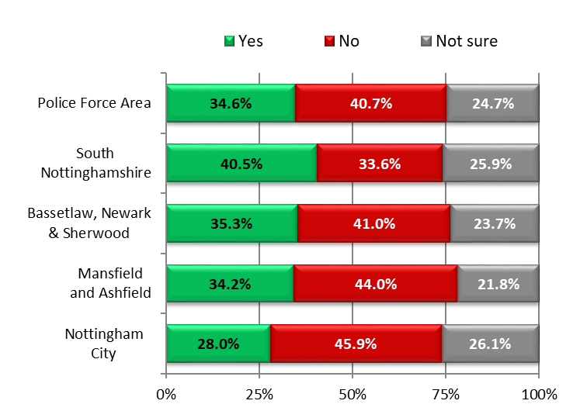
Responses by Community Safety Partnership area

YES : NO
excluding ‘not sure’

46.0% : 54.0%

54.6% : 45.4%

46.2% : 53.8%

43.8% : 56.2%

37.9% : 62.1%

  - Of the 40.7% of respondents that did not support an increase in the precept, the vast majority (83.3%) cited personal economic circumstances as the reason. This is comparable to the proportion recorded in 2020 (82.5%). The proportion of respondents feeling that the police did not need additional funding or would not use it wisely also remained stable at 16.7%.

  - In recognition of the need for more detailed information to inform resident decision making, qualitative feedback was obtained via four independently facilitated focus groups held during the week commencing 17 January 2021. The focus groups covered each of Nottinghamshire’s four Community Safety Partnership areas: Nottingham City; South Nottinghamshire; Bassetlaw, Newark and Sherwood; and Mansfield and Ashfield, and involved a combined total of 41 participants from a diverse range of backgrounds.

  - Focus groups provided an opportunity for more nuanced exploration of attitudes towards the precept for policing informed by details of the annual budget for policing including sources of income, current precept level and areas in which savings and efficiencies are being delivered. Participants were also informed of the areas which would receive additional investment in the event of a rise in the council tax precept.

  - In contrast to the survey findings, all focus groups indicated strong support for an increase in the precept for policing based on the information provided and the areas of investment outlined. 83% of participants (34) supported a £10 increase in 2022.

  - A common caveat to this support across all focus groups, however, was the call for “more accountability” and “more transparency” in the way additional precept revenue was being invested. Some participants also felt that the provision of more statistical data on social media would help to ensure residents receive evidence of the impact of additional investment.

“I support it, but also would like to see more transparency of how the investment
was targeted and performance was measured”

“Yes, I would be happy to pay it, but there needs to be some accountability. How do the police demonstrate this to us? They could post statistics, may be through social media. As an example, I don’t know where the additional £6 from last year went or what impact it had”

  - Reflecting findings from the Police and Crime Survey, those that opposed an increase in the precept for policing typically referenced financial challenges as the main issue as opposed to explicitly not wanting to support an increase in police funding and resources.

“It is a very poor time to be asking people for more money, the cost of living has gone up,
while household incomes haven’t, and in plenty of cases, they have gone down”

COUNCIL TAX REFERENDUMS

The Localism Act 2011 requires authorities including Police & Crime Commissioners to determine whether their ‘relevant basic amount of council tax’ for a year is excessive, as excessive increases trigger a council tax referendum. The Secretary of State is required to set out principles annually, determining what increase is excessive. For 2022-23 the principles state that, for Police & Crime Commissioners, an increase of more than £10 in the basic amount of council tax between 2021-22 and 2022-23 is excessive.
For 2022-23 the relevant basic amount is calculated as follows: Formula:
Council Tax Requirement Total tax base for police authority area
= Relevant basic amount of council tax

Nottinghamshire 2022-23 estimated calculation:

£83,253,102.27 = £254.25
327,445.83 (+£9.99)

An increase of £9.99 is below the threshold amount.

RECOMMENDATION ON THE LEVEL OF POLICE & CRIME PRECEPT ON THE COUNCIL TAX

As discussed in the Budget report resources have been allocated to support the police and crime plan. In assessing appropriate spending levels, consideration has been given to the significant unavoidable commitments facing the Police & Crime Commissioner, including the 20,000 uplift in Police Officer numbers nationally, pay awards and pension liabilities. Due regard has been given to the overall cost to the local council tax payer. Consideration has also been given to the projected value of the available reserves and balances and the medium term financial assessment (both reported separately).

The Commissioners proposed spending plans for 2022-23 result in a Police and Crime Precept on the Council Tax of £254.25 for a Band D property, representing an increase of £9.99.

For comparison purposes the Council Tax for Precepting Authorities is always quoted for a Band D property. In Nottinghamshire by far the largest numbers of properties are in Band A.

To achieve a balanced budget and having regard for the provisional notification of grant income an increase in the Police & Crime Precept has been required. This is on top of budget reductions and efficiencies to be achieved in year.

The calculation of the Police & Crime Precept on the Council Tax is as follows:

 | 2021-22  Budget  £m |  | 2022-23  Budget  £m |  | Increase/ Decrease  £m
Budget | 233.2 |  | 247.7 |  | 14.5 | (+)
External Income | 154.7 | (-) | 163.2 | (-) | 8.5 | (-)
Collection Surplus/deficit | 0.1 | (-) | 0.8 | (-) | 0.7 | (-)
Reserves | 0.1 | (+) | 0.4 | (-) | 0.5 | (-)
Precept | 78.5 | (-) | 83.3 | (-) | 4.8 | (-)

Council Tax Changes:

Tax Base | 321,480 | 327,446 | 5,966
Council Tax Band D | £244.26 | £254.25 | £9.99
Council Tax Band A | £162.84 | £169.50 | £6.66

The overall Police & Crime Precept to be collected on behalf of the Police & Crime Commissioner for 2022-23 is:

£m
Budgeted Expenditure  Less income from: | 247.7 | (+)
Police & Crime Grant | 153.5 | (-)
Legacy Grant | 9.7 | (-)
Collection Fund surplus/deficit | 0.8 | (-)
Net contribution to/(from) Balances 0.4 (-)

Police & Crime Precept on the Council Tax
83.3 (-)

The resulting precept and Council Tax levels derived from the measures contained in this report are detailed below:

Police & Crime element of the Council Tax

Band | 2021-22  £ | 2022-23  £
A | 162.84 | 169.50
B | 189.98 | 197.75
C | 217.12 | 226.00
D | 244.26 | 254.25
E | 298.54 | 310.75
F | 352.82 | 367.25
G | 407.10 | 423.75
H | 488.52 | 508.50

Amounts to be raised from Council Tax in each billing authority area 2022-23:

 | Precept amount to be collected  £ | Collection Fund Surplus/(Deficit)  £ | Total amount due  £
Ashfield | 8,657,898.98 | 48,039.00 | 8,705,937.98
Bassetlaw | 9,253,888.94 | 58,453.00 | 9,312,341.94
Broxtowe | 8,779,252.50 | 25,973.00 | 8,805,225.50
Gedling | 9,604,654.79 | 0.00 | 9,604,654.79
Mansfield | 7,769,193.53 | 284,274.51 | 8,053,468.04
Newark & Sherwood | 10,476,371.25 | 267,321.40 | 10,743,692.65
Nottingham City | 17,172,045.00 | 220,294.00 | 17,392,339.00
Rushcliffe | 11,539,797.30 | (51,762.00) | 11,488,035.30
Total | 83,253,102.29 | 852,592.91 | 84,105,695.20

Collection Dates

The dates, by which the Commissioners bank account must receive the credit in equal instalments, otherwise interest will be charged.
2022 | £
20 April | 8,410,569.00
27 May | 8,410,569.00
01 July | 8,410,569.00
05 August | 8,410,569.00
12 September | 8,410,569.00
17 October | 8,410,569.00
21 November | 8,410,569.00
2022  04 January | 8,410,569.00

03 February 8,410,569.00
10 March 8,410,844.20
84,105,965.20

ROBUSTNESS OF THE ESTIMATES

The Chief Finance Officer to the Police & Crime Commissioner has worked closely with the Head of Finance (Nottinghamshire Police) to obtain assurance on the accuracy of the estimates provided. There have been regular meetings between the Commissioner, Chief Constable and their professional officers.

Information provided in the Spending Review and Settlement announcement have been fully factored in to these estimates.

The replenishment of reserves and the use of direct revenue financain has progressed and have been used to finance the new building on the Joint HQ site, which will be in full operation for the whole of 2022-23.

The budget proposed within this report represents a balanced budget. To achieve this, the force has provided detail on how efficiencies and savings will be delivered. There are some potential risks to the full amount of savings being achieved and this will be monitored monthly, with alternative savings needing to be identified if the initial plans cannot be delivered.

The balanced budget is based upon the recommended £9.99 band D increase in Council Tax for 2022-23.

S25 of the Local Government Act 2003 require the Chief Finance Officer to report on the adequacy of estimates for the coming financial year. The CFO is of the view that the estimates are robust as based on the following :

COST DRIVER | ESTIMATE
Officer uplift | Delivery of the Force share of the 20,000 national uplift is planned
Pay inflation | 2% - (with potential to reduce levels of direct revenue financing if final amounts are greater).
Vacancy levels for police staff | 3.5%
Pensions | 16.5% LGPS, 31.0% Police Officers
Non pay inflation | 0% to 10% (Fuel)
Taxbase growth and collection fund surplus/ deficits | This has been confirmed by billing authorities 1.92%
General Inflation | 2.5%
Police/Home Office IT charges | 10%
Insurance | 5%

Options of up to £12 and £24 are included on account of flexibility previously afforded, however it is recognised that any increase in excess of the £10 in 2022 would require a referendum costing an estimated £1m. The December 2021 settlement announced precept flexibility of up to £10 on a Band D property for 2022/23, 2023/24 and 2024/25, providing a greater degree of certainty. This will be reflected in options listed as part of the ongoing Police and Crime Survey consultation process.

