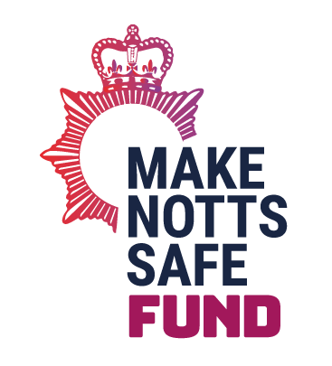
Make Notts Safe Thematic Grants 2022-23-2024/25

Youth Diversion Themed Grants
All funding is subject to organisations meeting specific funding criteria.
Organisation Name | Project Name | Brief Detail of Funded Project | Total Funded  May 22 -March 25  £
Newark Emmaus Trust | Activities for the Homeless | Mentoring and positive diversionary activities for homeless service users who are vulnerable and at risk of involvement in crime and anti-social behaviour. | £36,000
Trent Bridge Community Trust | Positive Futures | Provision of specialist youth workers to mentor targeted young people (aged 10-18) at risk of involvement in gangs/crime/social exclusion. Aim being to enrich lives, reduce negative/ criminal/ antisocial behaviours, provide structure/ guidance, develop skills, improve employability/ aspirations/ confidence. | £64,245
Switch Up | Switch Up | Diverting Nottingham’s vulnerable young people away from criminality and violence through intensive one to one targeted mentoring, personal development, physical activity (boxing) and counselling. | £38,637
3Pillars Project | GAMEPLAN | GAMEPLAN is a programme designed to divert and rehabilitate men aged 14-29 through sports-based mentoring. An early intervention, in custody and post-release method creating a long-term model for behaviour change. | £67,500
Support Through Sport Youth CIC | Support Through Sport Youth Diversion | Support Through Sport will engage with young people across Mansfield, Sutton-In-Ashfield and Stapleford – providing youth diversion activities and ongoing mentoring. | £35,880
The Centre Place | The Centre Place | Provision of a safe space for children & young people to access evening groups and social education workshops to protect and divert them away from crime and harm. | £30,214
Norman Galloway Homes | Project 3,6,9 | Care experienced young people will co-design a range of one to one and peer to peer activities that intensively support them each to find and sustain paid work therefore reducing their vulnerability to involvement in negative behaviours. | £27,125
TOTAL |  |  | £299,601

Hidden Harm Themed Grants
All funding is subject to organisations meeting specific funding criteria.
Organisation Name | Project Name | Brief Detail of Funded Project | Total Funded  22-25  £
POW Nottingham | POW’s Safeguarding Project | POW will work in partnership with the Police, Modern Slavery team and local services to increase safety and reduce harm for our hidden and vulnerable community members. | £35,268
Evolve Nottingham CIC | Evolve | This project supports young people by building on relationships of trust to provide a safe outlet for young people in telling their story, to ensure they have the support they deserve. | £36,000
Remedi | Restorative Choices – CCE/ Tools Down | Delivering CCE/County lines and Knife Crime workshops for young people and their care professionals, focusing on those most at risk of hidden harm, empowering understanding of choices/where to access support. | £46,250
Jericho Road Project | Outreach and Enablement | Provision of flexible, holistic and targeted support for women experiencing sexual exploitation and coercion. | £30,600
Base 51 | Safe Space | ‘Safe Space’ will deliver a holistic project, providing a person centered response to young people who have been exposed to or affected by hidden harm. | £46,474
Al-Hurraya | Educate to Eliminate | Provision of workshops to professionals from partner agencies who work with BAMER clients but have a lack of understanding and / or knowledge of the impact that Culture, Faith and Religion can have on their engagement, recovery or lack of Service User involvement. | £32,100
Nottingham Muslim Women’s Network | Engage, Inform, Empower – Community Activism | Support and awareness raising of hidden harm within the Muslim community through a community activist programme and delivery of a culturally competent Freedom Programmes. | £53,628
Mojatu Foundation | FGM Community Clinic and Connection Safe Space | Work in partnership with NHS and other Nottinghamshire organisations in establishing a safe, inviting and suitable space for FGM survivors to meet clinicians and get specialised support. | £34,830
TOTAL |  |  | £315,150

