**Treasury Management Strategy 2023-28 March 2023 (Finalised July 2023)**

Incorporating the Minimum Revenue Provision Policy Statement and Annual Investment Strategy 2023-28

**Contents**

## Introduction Pages 3 - 5

* 1. Background
  2. Reporting Requirements
  3. Treasury Management Strategy 2023-28
  4. Treasury Management Consultants
  5. Training

## The Capital Prudential Indicators 2023-24 to 2027-28 Pages 6 - 10

* 1. Capital Expenditure
  2. Commissioner’s borrowing need (Capital Financing Requirement)
  3. Liability Benchmark
  4. Minimum Revenue Provision (MRP) policy statement
  5. Core funds and expected investment balances
  6. Affordability
  7. Ratio of financing costs to net revenue stream
  8. Incremental impact of capital investment decisions on council tax

## Borrowing Pages 11 - 16

* 1. Current portfolio position
  2. Treasury Indicators - Limits to borrowing activity
  3. Prospects for interest rates and economic background
  4. Policy on borrowing in advance of need
  5. Debt rescheduling
  6. Borrowing Strategy and Municipal Bond Agency

## Annual Investment Strategy Pages 17 - 20

* 1. Investment policy
  2. Non-financial investments policy
  3. Creditworthiness policy
  4. Country limits
  5. Investment Strategy
  6. Investment risk benchmarking

## Section 151 Officer Page 21

* 1. Treasury Management role

1. **Treasury Management Practices (TMPs) Pages 22 - 25**
   1. TMPs 1 to 12

# INTRODUCTION

#### Background

The Nottinghamshire Office of the Police and Crime Commissioner (NOPCC) is required to operate a balanced budget, which broadly means that cash raised during the year will meet cash expenditure. Part of the treasury management operation is to ensure that this cash flow is adequately planned, with cash being available when needed. Surplus monies are invested in low-risk counterparties or instruments commensurate with the Police and Crime Commissioner’s low risk appetite, providing adequate liquidity initially before considering investment return, this approach also ensures that commercial investments are unlikely to be undertaken without additional PCC approval.

The second main function of the treasury management service is the funding of the Commissioner’s capital plans. These capital plans provide a guide to borrowing need, and longer-term cash flow planning to ensure that the NOPCC can meet its capital spending obligations. This management of longer-term cash may involve arranging long or short-term loans. If advantageous previous borrowing may be restructured to meet NOPCC risk or cost objectives.

The contribution the treasury management function makes to the organisation is critical, as the balance of debt and investment operations ensure liquidity or the ability to meet spending commitments as they fall due, either on day-to-day revenue or for larger capital projects. The treasury operations will see a balance of the interest costs of debt and the investment income arising from cash deposits affecting the available budget. Since cash balances generally result from reserves and balances, it is paramount to ensure adequate security of the sums invested, as a loss of principal will in effect result in a loss to the General Fund Balance.

The responsible officer for the operational treasury management is the Chief Finance Officer to the Chief Constable (CC CFO). The Chartered Institute of Public Finance and Accountancy (CIPFA) defines Treasury Management as:

*“The management of the organisation’s borrowing, investments, and cash flows, including its banking, money market and capital market transactions, the effective control of the risks associated with those activities, and the pursuit of optimum performance consistent with those risks.”*

The Chief Finance Officer to the Police and Crime Commissioner (PCC CFO) retains strategic responsibility, especially in determining the risk appetite and operational boundaries for day-to-day management of the function by the CC CFO.

#### Reporting requirements

The Police and Crime Commissioner (PCC) is required to receive and approve, as a minimum, three main Treasury Management reports each year, which incorporate a variety of polices, estimates and actuals.

* + 1. **Prudential and Treasury Indicators and Treasury Strategy (this report)** – The first and most important report covers:
    - the capital plans (see also the strategy report), prudential indicators and borrowing plans
    - a minimum revenue provision (MRP) policy, (how residual capital expenditure is charged to revenue over time)
    - the treasury management strategy, (how the investments and borrowings are to be organised) including treasury indicators; and
    - an investment strategy (the parameters on how investments are to be managed)
    1. **A mid-year Treasury Management Report** – This is primarily a progress report and will update the Commissioner on the capital position, amending prudential indicators as necessary. It also monitors whether the treasury activity is meeting the strategy and whether any policies require revision.
    2. **An Annual Treasury Report** – This is a backward-looking review document and provides details of a selection of actual prudential and treasury indicators and actual treasury operations compared to the estimates within the strategy.

The CIPFA 2021 Prudential and Treasury Management Codes also requires the PCC to prepare a Capital Strategy report which will provide the following: -

* a high-level long-term overview of how capital expenditure, capital financing and treasury management activity contribute to the provision of services
* an overview of how the associated risk is managed
* the implications for future financial sustainability

The aim of the capital strategy is to ensure that the overall long-term policy objectives and resulting Capital Strategy requirements, governance procedures and risk appetite is fully understood by stakeholders. This is contained in a separate report.

#### Scrutiny

The responsibility for scrutiny lies with the Commissioner supported by the Joint Independent Audit Committee (JIAC).

The values within the strategy have been rounded appropriately, and the extent of rounding is clearly labelled. This rounding will in some cases cause a note to be apparently mathematically incorrect.

**Other reports**

In addition to the three major reports detailed above, from 2023/24 quarterly reporting (end of June/end of December) is also required and will be reported to the appropriate JIAC Meeting to be adequately scrutinised.

#### Treasury Management Strategy 2023-28

The strategy covers two main areas:

#### Capital issues

* + - capital expenditure plans and the associated prudential indicators.
    - the minimum revenue provision (MRP) policy

#### Treasury management issues

* + - the current treasury position
    - treasury indicators which limit the treasury risk and activities of NOPCC
    - prospects for interest rates
    - the borrowing strategy
    - policy on borrowing in advance of need
    - debt rescheduling
    - the investment strategy
    - creditworthiness policy
    - the policy on use of external service providers

These elements cover the requirements of the Local Government Act 2003, the CIPFA Prudential Code, Department of Levelling Up Housing and Communities (DHCLG) MRP Guidance, the CIPFA Treasury Management Code and MDLUHC Investment Guidance.

#### Treasury management consultants

NOPCC uses the Link Group Treasury Services as its external treasury management advisors.

NOPCC recognises that responsibility for treasury management decisions remain with the organisation at all times and will ensure that undue reliance is not placed upon our external advisors. All decisions will be undertaken with regards to all available information, including, but not solely from, our treasury advisers.

NOPCC also recognises that there is value in employing external providers of treasury management services in order to acquire access to specialist skills and resources. The CFO’s will ensure that the terms of their appointment and the methods by which their value will be assessed are properly agreed and documented and subjected to regular review.

#### Training

The CIPFA Treasury Management Code requires that the responsible officer ensures that relevant personnel receive adequate training in treasury management. This especially applies to the Commissioner and members who are responsible for scrutiny.

Appropriate training will be provided to the PCC, any members of JIAC and other responsible officers/staff as soon as practicable and as a minimum within 12 months of starting their role, via our Treasury Advisors, Link Group Treasury Services Limited. A formal record of the training received by officers and members central to the Treasury function will be maintained by the Chief Accountant.

The training needs of treasury management officers are also periodically reviewed so they maintain continuous professional development as required by the CIPFA Code of Practice.

## THE CAPITAL PRUDENTIAL INDICATORS 2023-24 to 2027-28

The Commissioner’s capital expenditure plans are the key driver of treasury management activity. The output of the capital expenditure plans is reflected in the prudential indicators, to give an overview and confirm capital expenditure plans. Full information regarding capital expenditure plans is included within the separate capital strategy report and capital programme report.

#### Capital expenditure & financing

This prudential indicator is a summary of the Commissioner’s capital expenditure plans, both those agreed previously, and those forming part of this budget cycle.

The Commissioner is asked to approve the capital expenditure forecasts.

The table below summarises the updated capital expenditure plans as at the report date and how these plans are being financed by capital or revenue resources. Any shortfall of resources results in a net financing need.

|  |  |  |  |  |  |  |
| --- | --- | --- | --- | --- | --- | --- |
| **Table 1**  **Capital Expenditure** | **2022-23**  **Outturn\***  **£m** | **2023-24**  **Estimate**  **£m** | **2024-25**  **Estimate**  **£m** | **2025-26**  **Estimate**  **£m** | **2026-27**  **Estimate**  **£m** | **2027-28**  **Estimate**  **£m** |
| Estates | 4.364 | 5.248 | 2.116 | 2.174 | 2.234 | 2.296 |
| Information Services | 0.733 | 2.148 | 0.315 | 0.315 | 0.112 | 0.115 |
| Fleet | 1.519 | 4.418 | 3.451 | 2.696 | 2.432 | 1.591 |
| Other | 0.000 | 0.197 | 0.000 | 0.000 | 0.000 | 0.000 |
| **Capital Programme** | **6.616** | **12.011** | **5.882** | **5.185** | **4.778** | **4.002** |
| **Financed by:** |  |  |  |  |  |  |
| Capital Receipts | (0.200) | (1.395) | (0.300) | (0.300) | (0.300) | (0.300) |
| Capital Grants | 0.000 | 0.000 | 0.000 | 0.000 | 0.000 | 0.000 |
| Capital Contributions | 0.000 | (0.197) | 0.000 | 0.000 | 0.000 | 0.000 |
| Direct Revenue Financing | (4.300) | (0.600) | 0.000 | 0.000 | 0.000 | 0.000 |
| Capital Reserve | 0.000 | 0.000 | 0.000 | 0.000 | 0.000 | 0.000 |
| **Total Financed By:** | **(4.500)** | **(2.192)** | **(0.300)** | **(0.300)** | **(0.300)** | **(0.300)** |
|  |  |  |  |  |  |  |
| **Net Financing Need** | **2.116** | **9.819** | **5.582** | **4.885** | **4.478** | **3.702** |

*\* Both 2020/21 and 2021/22 Accounts are subject to audit, so the balances shown in the Outturn for 2022/23 are estimated.*

#### Commissioner’s borrowing need (Capital Financing Requirement)

The second prudential indicator is the Capital Financing Requirement (CFR). The CFR is simply the total historic outstanding capital expenditure, which has not yet been financed from either revenue or capital resources. It is essentially a measure of the underlying borrowing need after the application of other forms of capital resources have been applied, where possible these resources are applied to shorter life assets first. Any capital expenditure above, which has not immediately been financed, will increase the CFR. The CFR does not increase indefinitely, as the minimum revenue provision (MRP) offsets this cost. The MRP is a statutory annual revenue charge that broadly reduces the borrowing need in line with each asset’s life.

The CFR includes any other long-term liabilities (e.g., PFI Schemes and finance leases). Whilst these increase the CFR, and therefore the borrowing requirement, these types of schemes include a borrowing facility by the provider and so the Commissioner is not required to borrow separately for these schemes.

The Commissioner is asked to approve the CFR projections below:

|  |  |  |  |  |  |  |
| --- | --- | --- | --- | --- | --- | --- |
| **Table 2**  **Movement in CFR represented by** | **2022-23**  **Outturn\***  **£m** | **2023-24**  **Estimate**  **£m** | **2024-25**  **Estimate**  **£m** | **2025-26**  **Estimate**  **£m** | **2026-27**  **Estimate**  **£m** | **2027-28**  **Estimate**  **£m** |
| Net financing need for the year (above) | 2.116 | 9.819 | 5.582 | 4.885 | 4.478 | 3.702 |
| Less MRP/VRP and other  financing movements | (3.338) | (3.759) | (3.903) | (4.243) | (4.538) | (4.789) |
| **Movement in CFR** | (1.222) | 6.060 | 1.679 | 0.642 | (0.060) | (1.087) |

|  |  |  |  |  |  |  |
| --- | --- | --- | --- | --- | --- | --- |
| **Table 3**  **Capital Financing Requirement (CFR)** | **2022-23**  **Outturn\***  **£m** | **2023-24**  **Estimate**  **£m** | **2024-25**  **Estimate**  **£m** | **2025-26**  **Estimate**  **£m** | **2026-27**  **Estimate**  **£m** | **2027-28**  **Estimate**  **£m** |
| **Opening CFR** | 66.355 | 65.134 | 71.194 | 72.873 | 73.514 | 73.454 |
| **Movement in CFR (Table 2)** | (1.222) | 6.060 | 1.679 | 0.642 | (0.060) | (1.087) |
| **Closing CFR** | 65.134 | 71.194 | 72.873 | 73.514 | 73.454 | 72.368 |

*\* Both 2020/21 and 2021/22 Accounts are subject to audit, so the balances shown in the Outturn for 2022/23 are estimated.*

#### Liability Benchmark

A third and new prudential indicator for 2023/24 is the Liability Benchmark (LB). The Authority is required to estimate and measure the LB for the forthcoming financial year and the following two financial years, as a minimum.

There are four components to the LB: -

1. **Existing loan debt outstanding**: the Authority’s existing loans that are still outstanding in future years.
2. **Loans CFR**: this is calculated in accordance with the loans CFR definition in the Prudential Code and projected into the future based on approved prudential borrowing and planned MRP.
3. **Net loans requirement**: this will show the Authority’s gross loan debt less treasury management investments at the last financial year-end, projected into the future and based on its approved prudential borrowing, planned MRP and any other major cash flows forecast.
4. **Liability benchmark (or gross loans requirement):** this equals net loans requirement plus short-term liquidity allowance.

|  |  |  |  |  |  |  |
| --- | --- | --- | --- | --- | --- | --- |
| **Liability Benchmark** | **2022-23**  **Outturn\***  **£m** | **2023-24**  **Estimate**  **£m** | **2024-25**  **Estimate**  **£m** | **2025-26**  **Estimate**  **£m** | **2026-27**  **Estimate**  **£m** | **2027-28**  **Estimate**  **£m** |
| Existing Loan Debt Outstanding | 74.273 | 63.240 | 59.079 | 58.041 | 54.502 | 53.464 |
| Net Loans Requirement | 65.777 | 71.837 | 73.516 | 74.157 | 74.098 | 73.011 |
| Loans CFR | 65.134 | 71.194 | 72.873 | 73.514 | 73.454 | 72.367 |
| Liquidity allowance above net debt (liquidity buffer) | 10.000 | 10.000 | 10.000 | 10.000 | 10.000 | 10.000 |
| **Liability Benchmark** | **75.777** | **81.837** | **83.516** | **84.157** | **84.098** | **83.011** |

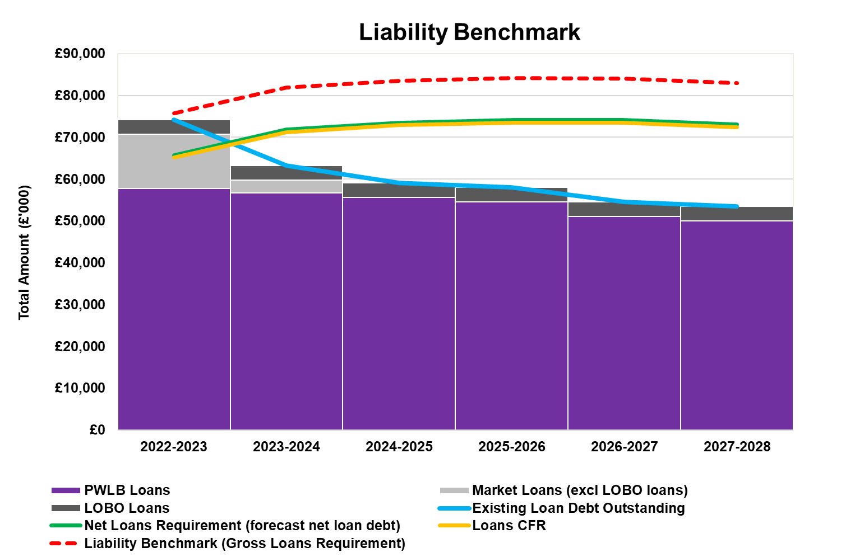

#### Minimum Revenue Provision (MRP) policy statement

The PCC is required to pay off an element of the accumulated capital spend each year (the CFR) and make a statutory charge to revenue for the repayment of debt, known as the Minimum Revenue Provision (MRP). The MRP policy sets out how the PCC will pay for capital assets through revenue each year. The PCC is also permitted to make additional Voluntary Revenue Payments (VRP).

A change introduced by the revised DLUHC MRP Guidance was the allowance that any charges made over the statutory minimum revenue provision (MRP), voluntary revenue provision or overpayments, can, if needed, be reclaimed in later years if deemed necessary or prudent. In order for these sums to be reclaimed for use in the budget, this policy must disclose the cumulative overpayment made each year.

The additional provision that has been made to date is shown in the table below:

|  |  |
| --- | --- |
| **Additional Revenue Provision** | **£m** |
| 2016-17 | 0.750 |
| 2017-18 | 0.250 |
| 2019-20 | 0.800 |
| **Total Additional Provision** | **1.800** |

DLUHC regulations have been issued, which require the Commissioner to approve an MRP Statement in advance of each year. A variety of options are available to the Commissioner, as long as there is a prudent provision. No changes are proposed from the existing policy. The Commissioner is recommended to approve the following MRP Statement:

* for capital expenditure incurred before 1 April 2008, MRP will be based on the Regulatory Method. MRP will be written down over a fixed 50 year period
* for capital expenditure incurred from 1 April 2008, the MRP will be based on the ‘Asset Life Method’, whereby MRP will be based on the estimated life of the assets requiring financing as follows:
  + Land – 50 years
  + Buildings – 25 years
  + Plant & Equipment – 7 years
  + Fleet/Vehicles – Up to 6 years
* for finance leases, an ‘MRP equivalent’ sum will be paid off each year.

#### Core funds and expected investment balances

Investments will be made with reference to the core balances, future cash flow requirements and the outlook for short-term interest rates (i.e., rates for investments up to 12 months).

Table 6 below provides an estimate of the year-end balances for each resource and anticipated day to day cash flow balances.

|  |  |  |  |  |  |  |
| --- | --- | --- | --- | --- | --- | --- |
| **Table 6 – Core Funds &**  **Expected Investment Balances** | **2022-23**  **Outturn\***  **£m** | **2023-24**  **Estimate**  **£m** | **2024-25**  **Estimate**  **£m** | **2025-26**  **Estimate**  **£m** | **2026-27**  **Estimate**  **£m** | **2027-28**  **Estimate**  **£m** |
| Fund Balances/Reserves (exc JOs) | 27.399 | 23.188 | 23.078 | 24.368 | 21.958 | 21.148 |
| Capital Receipts Reserve | 0.000 | 0.000 | 0.000 | 0.000 | 0.000 | 0.000 |
| Provisions | 4.045 | 4.045 | 4.045 | 4.045 | 4.045 | 4.045 |
| Cash and Bank | 9.783 | 9.783 | 9.783 | 9.783 | 9.783 | 9.783 |
| **Total Core Funds** | **41.227** | **37.016** | **36.906** | **38.196** | **35.786** | **34.976** |
| **Working Capital\*\*** | **(1.207)** | **(1.207)** | **(1.207)** | **(1.207)** | **(1.207)** | **(1.207)** |
| **(Under)/Over borrowing** | **(0.861)** | **(1.454)** | **(2.294)** | **0.526** | **1.548** | **5.097** |
| **Expected Investments** | **39.159** | **34.355** | **33.405** | **37.515** | **36.127** | **38.866** |

*\*Both 2020/21 and 2021/22 Accounts are subject to audit, so the working capital balances shown in the Outturn for 2022/23 are estimated.*

*\*\*Working capital balances shown are estimated year-end; these may fluctuate during the year*

#### Affordability Prudential Indicators

The previous sections cover the overall capital and control of borrowing prudential indicators, but within this framework prudential indicators are required to assess the

affordability of the capital investment plans. These provide an indication of the impact of the capital investment plans on the Commissioners overall finances.

### The Commissioner is requested to approve the following indicators:

#### Ratio of financing costs to net revenue stream

This indicator identifies the trend in the cost of capital (borrowing and other long term obligation costs net of investment income) against the net revenue stream. This indicator is not a mandatory indicator under the revised code, but it has been reviewed and considered a good indication of the commitment from capital spending.

The estimates of financing costs include current commitments and a reasonable assessment of forthcoming capital proposals.

|  |  |  |  |  |  |  |
| --- | --- | --- | --- | --- | --- | --- |
| **Ratio** | **2022-23**  **Outturn\*** | **2023-24**  **Estimate** | **2024-25**  **Estimate** | **2025-26**  **Estimate** | **2026-27**  **Estimate** | **2027-28**  **Estimate** |
|  | 2.0% | 2.7% | 2.5% | 2.4% | 2.5% | 2.2% |

*\*Both 2020/21 and 2021/22 Accounts are subject to audit, so the working capital balances shown in the Outturn for 2022/23 are estimated.*

#### Incremental impact of capital investment decisions on council tax

This indicator identifies the revenue costs associated with a reasonable assessment of forthcoming capital proposals, compared to the Commissioners existing approved commitments and current plans. The assumptions are based on current plans, but will invariably include some estimates, such as the level of Government support, which is not published over a three-year period. Again, this indicator is not a mandatory indicator under the revised code, but it has been reviewed and considered a good indicator of the commitment from capital spending.

#### Incremental impact of capital investment decisions on the band D council tax

|  |  |  |  |  |  |  |
| --- | --- | --- | --- | --- | --- | --- |
| **Ratio** | **2022-23**  **Outturn\*** | **2023-24**  **Estimate** | **2024-25**  **Estimate** | **2025-26**  **Estimate** | **2026-27**  **Estimate** | **2027-28**  **Estimate** |
|  | £0.00 | £0.00 | £1.96 | £3.05 | £4.19 | £4.95 |

*\** *Both 2020/21 and 2021/22 Accounts are subject to audit, so the working capital balances shown in the Outturn for 2022/23 are estimated.*

The graph below shows the financial impact of capital expenditure and borrowing on the Revenue Account:

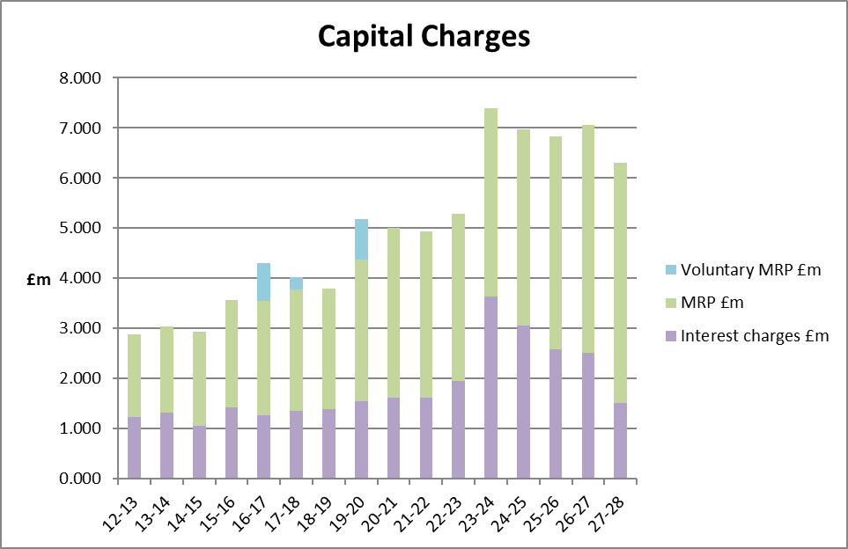

1. **BORROWING**

The treasury management function ensures that the Commissioner’s cash is organised in accordance with the relevant professional codes, so that sufficient cash is available to meet the capital expenditure plan summarised in Section 2. This will involve both the organisation of the cash flow, including the arrangement of borrowing as appropriate. The strategy covers the relevant treasury/prudential indicators, the current and projected debt positions, and the annual investment strategy.

#### Current portfolio position

The Commissioner’s borrowing portfolio position at March 2023, with forward projections is summarised below. The table shows the investment portfolio projected at the end of 2022/23 and the external loan/debt.

|  |  |
| --- | --- |
| **Table 3.1 - Investments Portfolio** | **2022-23 Outturn*  £m** |
| Guildford BC | 8,000 |
| Thurrock Council | 8,000 |
| Watford BC | 8,000 |
| North Lanarkshire 1 | 3,000 |
| West Dunbartonshire | 8,000 |
| North Lanarkshire 2 | 5,000 |
| South Somerset | 8,000 |
|  | **48,000** |
| **Plus LVNAVs (Low Volatility Net Asset Value”) Money Market Funds**  (estimated figure based on cashflow at 14032023) | 22,398 |
| **Total investments** | **70,398** |
|  |  |
| **Less Current Loans** |  |
| Market Loan - Elmbridge Borough Council (2) | 3,000 |
| Market Loan - Middlesborough Council | 5,000 |
| Market Loan - Cambridge City Council | 5,000 |
| Market Loan - Danske Bank (LOBO) | 3,500 |
| PWLB Loans (Maturity & EIP) | 57,773 |
| **Total Loans** | **74,273** |
|  |  |
| **Net Loan Position Estimated @ 31/03/2023** | **-3,875** |

Within the prudential indicators there are a number of key indicators to ensure that activities operate within well-defined limits. One of these is that the Commissioner needs to ensure that their gross debt does not (except in the short term), exceed the total of the CFR in the preceding year plus the estimates of any additional CFR for 2022-23 and the following two financial years. This allows some flexibility for limited early borrowing for future years but ensures that borrowing is not undertaken for revenue purposes.

The CFO reports that this prudential indicator will be complied with in the current year and does not envisage difficulties for the future. This view takes into account current commitments, existing plans, and the proposals in this budget report.

#### Treasury Indicators - Limits to borrowing activity

**Operational boundary**. This is the limit beyond which external debt is not normally expected to exceed. In most cases, this would be a similar figure to the CFR.

|  |  |  |  |  |  |  |
| --- | --- | --- | --- | --- | --- | --- |
| **Operational Boundary** | **2022-23**  **£m** | **2023-24**  **£m** | **2024-25**  **£m** | **2025-26**  **£m** | **2026-27**  **£m** | **2027-28**  **£m** |
|  | 85.000 | 85.000 | 85.000 | 85.000 | 85.000 | 85.000 |

**Authorised limit**. A further key prudential indicator representing a control on the maximum level of borrowing. This is a limit beyond which external debt is prohibited, and this limit needs to be set or revised by the Commissioner. It reflects the level of external debt which, while not desired, could be afforded in the short term, but is not sustainable in the longer term.

### The Commissioner is requested to approve the following authorised limit:

|  |  |  |  |  |  |  |
| --- | --- | --- | --- | --- | --- | --- |
| **Authorised Limit** | **2022-23**  **£m** | **2022-23**  **£m** | **2023-24**  **£m** | **2024-25**  **£m** | **2025-26**  **£m** | **2027-28**  **£m** |
|  | 90.000 | 90.000 | 90.000 | 90.000 | 90.000 | 90.000 |

The graph below shows CFR and debt figures from paragraphs 2.2 and 3.1 compared with relevant borrowing limits.

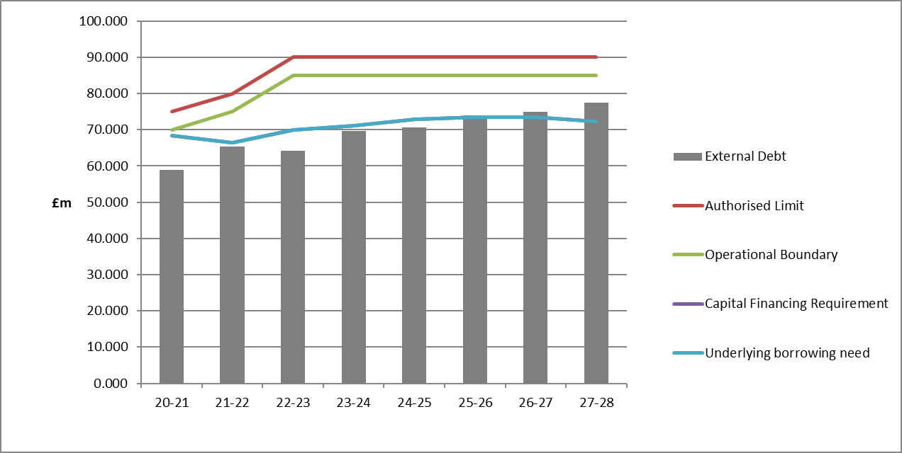

#### Prospects for interest rates and economic background

One of the services provided by Link Asset Services (Link) is to assist the Commissioner in formulating a view on interest rates. Link provided the following forecasts on 25 May 2023. These are forecasts for Bank Rate, average earnings and PWLB certainty rates, gilt yields plus 80 bps.

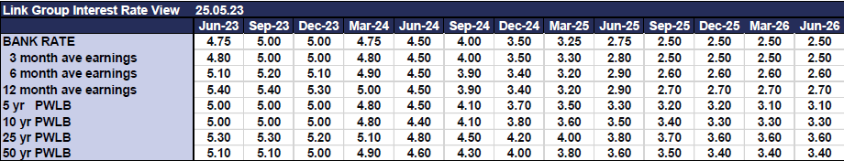

Additional notes by Link on this forecast table: -

* Our central forecast for interest rates was previously updated on 27 March and reflected a view that the MPC would be keen to further demonstrate its anti-inflation credentials by delivering a succession of rate increases. This has happened to a degree but with inflation remaining elevated we anticipate that Bank Rate will need to increase to at least 5%, if not higher, to sufficiently slow the UK economy and loosen the labour market.
* Moreover, we also still anticipate the Bank of England will be keen to loosen monetary policy when the worst of the inflationary pressures are behind us – but that timing will remain one of fine judgment: cut too soon, and inflationary pressures may well build up further; cut too late and any downturn or recession may be prolonged. Our current judgment is that rates will have to increase and stay at their peak until the spring of 2024 as a minimum.
* In the upcoming months, our forecasts will be guided not only by economic data releases and clarifications from the MPC over its monetary policies and the Government over its fiscal policies, but the on-going conflict between Russia and Ukraine. (More recently, the heightened tensions between China/Taiwan/US also have the potential to have a wider and negative economic impact.)
* On the positive side, consumers are still estimated to be sitting on significant excess savings left over from the pandemic, which could cushion some of the impact of the above challenges and may be the reason why the economy is performing somewhat better at this stage of the economic cycle than may have been expected. However, most of those excess savings are held by more affluent people whereas lower income families already spend nearly all their income on essentials such as food, energy and rent/mortgage payments.

PWLB RATES

* Gilt yield curve movements have shifted upwards in recent days but remain relatively volatile. PWLB 5 to 50 years Certainty Rates are, generally, in the range of 4.75% to 5.50%.
* Link view the markets as having recalibrated the level of reward required by investors to hold UK sovereign debt (c0.75% higher than in March).

The balance of risks to the UK economy: -

* The overall balance of risks to economic growth in the UK is to the downside.

Downside risks to current forecasts for UK gilt yields and PWLB rates include: -

* **Labour and supply shortages** prove more enduring and disruptive and depress economic activity (accepting that in the near-term this is also an upside risk to inflation and, thus, the rising gilt yields we have seen of late).
* **The Bank of England** increases Bank Rate too fast and too far over the coming months, and subsequently brings about a deeper and longer UK recession than we currently anticipate.
* **UK / EU trade arrangements** – if there was a major impact on trade flows and financial services due to complications or lack of co-operation in sorting out significant remaining issues.
* **Geopolitical risks,** for example in Ukraine/Russia, China/Taiwan/US, Iran, North Korea and Middle Eastern countries, which could lead to increasing safe-haven flows.
* **A broadening of banking sector fragilities,** which have been successfully addressed in the near-term by central banks and the market generally, but which may require further intervention if short-term interest rates stay elevated for longer than is anticipated.

Upside risks to current forecasts for UK gilt yields and PWLB rates: -

* The **Bank of England continues to be too timid** in its pace and strength of increases in Bank Rate and, therefore, allows inflationary pressures to remain elevated for a longer period within the UK economy, which then necessitates Bank Rate staying higher for longer than we currently project.
* **The pound weakens** because of a lack of confidence in the UK Government’s fiscal policies, resulting in investors pricing in a risk premium for holding UK sovereign debt.
* Longer-term **US treasury yields** rise strongly if inflation remains more stubborn than the market currently anticipates, pulling gilt yields up higher consequently.
* Projected **gilt issuance, inclusive of natural maturities and QT,** could be too much for the markets to comfortably digest without higher yields compensating.

Borrowing advice:

* Links long-term (beyond 10 years) forecast for Bank Rate stands at 2.5%. As all PWLB certainty rates are currently above this level, borrowing strategies will need to be reviewed in that context. Better value can generally be obtained at the shorter end of the curve and short-dated fixed LA to LA monies should be considered. Temporary borrowing rates will remain elevated for some time to come but may prove the best option whilst the market continues to wait for inflation, and therein gilt yields, to drop back later in 2023 and 2024.

Links suggested budgeted earnings rates for investments up to about three months’ duration in each financial year are rounded to the nearest 10bps as follows: -

|  |  |
| --- | --- |
| Average earnings in each year |  |
| 2023/24 | 4.90% |
| 2024/25 | 3.80% |
| 2025/26 | 2.60% |
| 2026/27 | 2.50% |
| Years 6 to 10 | 2.80% |
| Years 10+ | 2.80% |

As there are so many variables at this time, caution must be exercised in respect of all interest rate forecasts.

#### Treasury Management limits on activity

There are three debt related treasury activity limits. The purpose of these are to constrain the activity of the treasury function within certain limits, thereby managing risk and reducing the impact of any adverse movement in interest rates. However, if these are set too restrictively, they will impair the opportunities to reduce costs/improve performance.

The indicators are:

* **Upper limits on variable interest rate exposure**. This identifies a maximum limit for variable interest rates based upon the debt position net of investments
* **Upper limits on fixed interest rate exposure**. This gives a maximum limit on fixed interest rates.
* **Maturity structure of borrowing**. These gross limits are set to reduce the exposure to large fixed rate sums falling due for refinancing.

### The Commissioner is requested to approve the following treasury indicators and limits:

|  |  |  |
| --- | --- | --- |
| **Upper Interest rate exposures 2023-24** | | |
| **Limits on fixed interest rates:**   * **Debt only** * **Investments only** | | 100%  100% |
| **Limits on variable interest rates**   * **Debt only** * **Investments only** | | 50%  100% |
| **Maturity structure of fixed interest rate borrowing 2023-24** | | |
|  | **Lower** | **Upper** |
| Under 12 months | 0% | 30% |
| 12 months to 2 years | 0% | 40% |
| 2 years to 5 years | 0% | 50% |
| 5 years to 10 years | 0% | 70% |
| 10 years and above | 0% | 100% |

#### Policy on borrowing in advance of need

The PCC will not borrow more than, or in advance of its needs purely in order to profit from the investment of extra sums borrowed. Any decision to borrow in advance will be within forward approved Capital Financing Requirement estimates and will be considered carefully to ensure that value for money can be demonstrated and that the security of such funds is considered.

Borrowing in advance will be made within the following constraints:

* + - It will be limited to no more than 50% of the expected increase in borrowing need (CFR) over the three-year planning period
    - Would not be more than 18 months in advance of need

Risks associated with any borrowing in advance activity will be subject to prior appraisal and subsequent reporting through the mid-year or annual reporting mechanism.

#### Debt rescheduling

Rescheduling of current borrowing in our debt portfolio is unlikely to occur, however any rescheduling will be approved by the Commissioner.

#### Borrowing Strategy and Municipal Bond Agency

It is possible that the Municipal Bond Agency, will offer loans to Local Authorities at borrowing rates lower than those offered by the Public Works Loan Board (PWLB). The Commissioner intends to make use of this new source of borrowing if rates are favourable.

# ANNUAL INVESTMENT STRATEGY

#### Investment Policy

The Commissioner’s investment policy has regard to the following: -

* + - DLUHC’s Guidance on Local Government Investments (“the Guidance”)
    - CIPFA Treasury Management in Public Services Code of Practice and Cross Sectoral Guidance Notes 2017 (“the Code”)
    - CIPFA Treasury Management Guidance Notes 2018

The Commissioner’s investment priorities will be security first, liquidity second and then return.

In accordance with guidance from the DLUHC and CIPFA, and in order to minimise the risk to investments, the PCC has below clearly stipulated the minimum acceptable credit quality of counterparties for inclusion on the lending list. This enables diversification and avoids the concentration of risk. The key ratings used to monitor counterparties are the Short Term and Long-Term ratings.

The aim of the strategy is to generate a list of highly creditworthy counterparties which will also enable diversification and thus avoidance of concentration risk. Therefore, providing security of investment and minimisation of risk.

Ratings will not be the sole determinant of the quality of an institution; it is important to continually assess and monitor the financial sector on both a micro and macro basis and in relation to the economic and political environments in which institutions operate. The assessment will also take account of information that reflects the opinion of the markets, by actively engaging with advisors to maintain monitoring on market pricing such as “credit default swaps” and overlay that information on top of the credit ratings.

Other information sources used will include the financial press, share price and other such information regarding the banking sector. This allows a robust scrutiny process on investment counterparties.

At the end of the financial year, the CFO will report on the investment activity as part of the Annual Treasury Report.

#### Non-financial Investments Policy

Non-financial investments are essentially the purchase of income yielding assets. Currently radio masts are held and income is received for an item that is no longer operational. They were not acquired with that as a purpose and were originally operational. The current income yield is circa £0.090m per annum. There is no intention to purchase these kinds of investments and any divergence from this would be the subject of a future report.

#### Creditworthiness Policy

On the advice of our Treasury Management Specialists, Link Group Limited we are now moving away from the use of a single credit ratings agency to a blended approach as this is more interactive and is in line with our risk appetite, especially as the money markets become more volatile

This service employs a sophisticated modelling approach utilising credit ratings from the three main credit rating agencies - Fitch, Moody’s and Standard & Poor’s. The credit ratings of counterparties are supplemented with the following overlays: -

1. “watches” and “outlooks” from credit rating agencies;
2. CDS spreads that may give early warning of changes in credit ratings;
3. sovereign ratings to select counterparties from only the most creditworthy countries.

This modelling approach combines credit ratings, and any assigned Watches and Outlooks, in a weighted scoring system which is then combined with an overlay of CDS spreads. The end-product of this is a series of colour coded bands which indicate the relative creditworthiness of counterparties. These colour codes are used by the Authority to determine the suggested duration for investments. The Authority will, therefore, use counterparties within the following durational bands*:*

* **Yellow** 5 years
* **Dark Pink** 5 years for Ultra-Short Dated Bond Funds with a credit score of 1.25
* **Light Pink** 5 years for Ultra-Short Dated Bond Funds with a credit score of 1.5
* **Purple** 2 years
* **Blue** 1 year (only applies to nationalised or semi nationalised UK Banks)
* **Orange** 1 year
* **Red**  6 months
* **Green**  100 days
* **No Colour** not to be used

The Link creditworthiness service uses a wider array of information other than just primary ratings. Furthermore, by using a risk weighted scoring system, it does not give undue preponderance to just one agency’s ratings.

Typically, the minimum credit ratings criteria the Authority uses will be a short-term rating (Fitch or equivalents) of F1 and a long-term rating of A-. There may be occasions when the counterparty ratings from one rating agency are marginally lower than these ratings but may still be used.  In these instances, consideration will be given to the whole range of ratings available, or other topical market information, to support their use.

All credit ratings will be monitored regularly. The Authority is alerted to changes to ratings of all three agencies through its use of the Link creditworthiness service.

* if a downgrade results in the counterparty / investment scheme no longer meeting the Authority’s minimum criteria, its further use as a new investment will be withdrawn immediately.
* in addition to the use of credit ratings the Authority will be advised of information in movements in Credit Default Swap spreads against the iTraxx European Senior Financials benchmark and other market data on a daily basis via its Passport website, provided exclusively to it by Link. Extreme market movements may result in downgrade of an institution or removal from the Authority’s lending list.

Sole reliance will not be placed on the use of this external service. In addition, this Authority will also use market data and market information, as well as information on any external support for banks to help support its decision-making process.



|  |  |  |  |  |
| --- | --- | --- | --- | --- |
|  | **Colour (and long-term rating where applicable)** | **Money and %\***  **limit** | **Transaction limit (/**)** | **Time limit** |
| **Banks \*** | **Yellow** | **£100m / 100%** | **£15m/£20m** | **2 yrs** |
| **Banks** | **Purple** | **£50m / 50%** | **£8m/£10m** | **2 yrs** |
| **Banks** | **Orange** | **£25m / 25%** | **£5m/£8m** | **1 yr** |
| **Banks – part nationalised** | **Blue** | **£15m / 15%** | **£5m/£8m** | **1 yr** |
| **Banks** | **Red** | **£15m / 15%** | **£4m/£5m** | **6 mths** |
| **Banks** | **Green** | **£0m / 0%** | **£Nil** | **100 days** |
| **Banks** | **No Colour** | **Not to be used** | **£Nil** | **N/A** |
| **Limit 3 category – Authority’s banker (where “No Colour”)** | **No Colour** | **Not to be used** | **£Nil** | **N/A** |
| **DMADF** | **UK sovereign rating** | **unlimited** | **unlimited** | **6 months** |
| **Local authorities** | **n/a** | **£100m / 100%** | **£10m/£15m** | **2 yrs** |
|  | **Fund rating\*\*** | **Money and/or % Limit** | **Transaction limit** | **Time Limit** |
| **Money Market Funds CNAV** | **AAA** | **£100m / 100%** | **£15m/£20m** | **liquid** |
| **Money Market Funds LVNAV** | **AAA** | **£100m / 100%** | **£15m/£20m** | **liquid** |
| **Money Market Funds VNAV** | **AAA** | **£100m / 100%** | **£15m/£20m** | **liquid** |
| **Ultra-Short Dated Bond Funds with a credit score of 1.25** | **Dark Pink / AAA** | **£100m / 100%** | **£15m/£20m** | **liquid** |
| **Ultra-Short Dated Bond Funds with a credit score of 1.50** | **Light Pink / AAA** | **£100m / 100%** | **£15m/£20m** | **liquid** |

*\*Based on Total Maximum investments of £100m. Limits relate to category as a whole, not individual banks / LA’s*

*/** = subject to PCC CFO Approval*

The Commissioner has determined that they will only use approved counterparties from countries with a minimum sovereign credit rating of AA- from Fitch.

#### Investment Strategy

**In-house funds.** Investments will be made with reference to the core balance and cash flow requirements and the outlook for short-term interest rates (up to 12 months). While most cash balances are required in order to manage the ups and downs of cash flow, where cash sums can be identified that could be invested for longer periods, the value to be obtained from longer term investments will be carefully assessed.

* + - If it is thought that Bank Rate is likely to rise significantly within the time horizon being considered, then consideration will be given to keeping most investments as being short term or variable.
    - Conversely, if it is thought that Bank Rate is likely to fall within that time period, consideration will be given to locking in higher rates currently obtainable, for longer periods.

**Investment returns expectations –** TheBank of England’s Bank Rate is expected to reach 4.5% in Q2 2023 which is having a positive impact on investment returns from money market-related instruments. As there are so many variables at this time, caution must be exercised in respect of all interest rate forecasts.

The suggested budgeted investment earnings rates for returns on investments placed for periods up to about six months during each financial year are as follows:

|  |  |
| --- | --- |
| **Average earnings in each year** | **Proposed**  **%\*** |
| 2022-23 | 1.30** |
| 2023-24 | 4.90 |
| 2024-25 | 3.80 |
| 2025-26 | 2.60 |
| 2026-27 | 2.50 |
| 2027-28 | 2.80 |

*\*Based on 6-month SONIA Figures* *(LIBOR and LIBID rates ceased at the end of 2021 and LIBOR has been replaced by a rate based on SONIA (Sterling Overnight Index Average).*

*\*\* This is a blended rate for 2022/23*

**Investment treasury indicator and limit** - total principal funds invested for greater than 365 days are limited with regard to liquidity requirements and to reduce the need for early redemption.

### The Commissioner is requested to approve the treasury indicator and limit:

|  |  |  |  |  |  |  |
| --- | --- | --- | --- | --- | --- | --- |
| **Maximum principal sums**  **invested > 365 days** | **2022-23**  **£m** | **2023-24**  **£m** | **2024-25**  **£m** | **2025-26**  **£m** | **2026-27**  **£m** | **2027-28**  **£m** |
|  | 10.000 | 10.000 | 10.000 | 10.000 | 10.000 | 10.000 |

There are currently no funds invested for greater than 365 days. For cash flow generated balances, the CFO will seek to utilise instant access and notice accounts, LVNAVs and short-dated deposits (overnight to 100 days) in order to benefit from the compounding of interest. Ultra-Short Dated Bond Funds will be used if considered appropriate by the CFO.

Any investment over 365 days requires the PCC CFO approval.

#### Investment Risk Benchmarking

These benchmarks are simple guides to maximum risk, and may be breached occasionally, depending on circumstances. The purpose of the benchmarks is that officers will monitor the current and trend position and amend the operational strategy to manage risk as conditions change. Any breach of the benchmarks will be reported, with supporting reasons in the mid-year or Annual Report.

**Security** - The Commissioner’s maximum security risk benchmark for the current portfolio, when compared to these historic default tables, is 0.06% historic risk of default when compared to the whole portfolio.

**Liquidity** - in respect of this area the Commissioner seeks to maintain:

* + - Bank overdraft - avoided if possible
    - Liquid short-term deposits of at least £0.5m available on instant access
    - Weighted average life benchmark is expected to be 1 month, with a maximum of 6 months

**Yield** - local measures of yield benchmarks is that investments achieve returns above the 7-day LIBID rate.

# 5 SECTION 151 OFFICER

#### Strategic Management Role

The S151 (responsible) officer is the Chief Financial Officer to the Police and Crime Commissioner (PCC), and they have the following strategic responsibilities:

* + - Recommending clauses, treasury management policy/practices for approval, reviewing the same regularly, and monitoring compliance
    - Receiving and reviewing management information reports
    - Ensuring the adequacy of internal audit, and liaising with external audit
    - Recommending the Treasury Management Strategy to the PCC for approval
    - Authorising use of higher / longer investment amounts and terms in line with the strategy

#### Operational Management Role

The S151 (responsible) officer is the Chief Financial Officer to the Chief Constable (CC), and they have the following responsibilities:

* + - Submitting regular treasury management policy reports
    - Submitting budgets and budget variations
    - Receiving and reviewing management information reports
    - Reviewing the performance of the treasury management function
    - Ensuring the adequacy of treasury management resources and skills, and the effective division of responsibilities within the treasury management function
    - Ensuring the adequacy of internal audit, and liaising with external audit
    - Recommending the appointment of external service providers
    - Preparation of a capital strategy to include capital expenditure, capital financing and treasury management, with a long-term timeframe.

# TREASURY MANAGEMENT PRACTICES

# CIPFA recommends that all public service organisations adopt, as part of their standing orders, financial regulations or other formal policy documents, appropriate to their circumstances, suitable Treasury Management Practices (TMPs) setting out the manner in which the organisation will seek to achieve the policies and objectives for Treasury Management and prescribing how it will manage and control those activities. The below Appendix sets out the TMPs for Nottinghamshire.

1. **TMP1** – **Treasury Risk Management**
   1. The CC Chief Finance Officer shall:

* Design, implement and monitor all arrangements for the identification, management and control of the treasury management risks shown below;
* Report at least annually on the adequacy/suitability thereof; and
* Report, as a matter of urgency, the circumstances of any actual or likely difficulty in achieving the PCC's objectives in this respect, all in accordance with the procedures set out in **TMP6** Reporting requirements and management information arrangements.
  1. Liquidity

The CC CFO will ensure adequate but not excessive cash resources, borrowing arrangements, overdraft or standby facilities to enable at all times to have the level of funds available which are necessary for the achievement of service objectives.

* 1. Interest Rates

The CC CFO will manage exposure to fluctuations in interest rates with a view to containment of net interest costs, or securing interest revenues, in accordance with the amounts provided in the Revenue Estimates in accordance with **TMP6** Reporting requirement and management information arrangement.

* 1. Credit and Counterparties

The PCC regards a prime objective of the treasury management activities to be the security of the principal sums invested. A formal counterparty list will be maintained by the CC CFO and the named organisations and limits will reflect a prudent attitude towards organisations with which funds may be deposited, and will limit the investment activities to the instruments, methods and techniques referred to in **TMP4** Approved Instruments, methods and techniques.

* 1. Re-scheduling and Re-financing of Debt

The CC CFO will ensure that all borrowing, private financing and partnership arrangements will be negotiated, structured and documented, and the maturity profile of debt will be managed with a view to obtaining terms for renewal or refinancing, if required, which are competitive and as favourable to the organisation as can reasonably be achieved in the light of market conditions prevailing at the time. Relationships with counterparties in these transactions will be managed in such a manner as to secure this objective and will avoid over-reliance on any one source of funding if this might jeopardise achievement of the above.

* 1. Legal and Regulatory

The CC CFO will ensure that all treasury management activities comply with the organisation’s statutory powers and regulatory requirements. The CC CFO will demonstrate such compliance, if required to do so, to all parties with whom he deals in such activities. In framing the credit and counterparty policy under **TMP1** Treasury Risk Management, the CC CFO will ensure that there is evidence of counterparties' powers, authority and compliance in respect of the transactions effected with the organisation, particularly with regard to duty of care and fees charged. With the aim to minimise the impact of future legislative or regulatory changes on treasury management activities so far as it is reasonably able to do so.

* 1. Fraud, Error and Corruption, and Contingency Management

The CC CFO will seek to ensure that the circumstances which may expose the organisation to the risk of loss through fraud, corruption or other eventualities in his treasury management dealings are identified. Accordingly, they will design and implement suitable systems and procedures and will maintain effective contingency management arrangements to counter such risks.

* 1. Market Risk

The CC CFO will seek to ensure that stated treasury management policies and objectives will not be compromised by adverse market fluctuations in the value of the principal sums invested.

1. **TMP2 - BEST VALUE AND PERFORMANCE MEASUREMENT** 
   1. The CC CFO will actively work to promote best value in treasury management activities. The treasury management function will be the subject of regular reviews to identify scope for improvement.
2. **TMP3 - DECISION-MAKING AND ANALYSIS**
   1. The CC CFO will maintain full records of treasury management decisions, and of the processes and practices applied in reaching those decisions to demonstrate that reasonable steps have been taken to ensure that all issues relevant to those decisions were taken into account.

1. **TMP4 - APPROVED INSTRUMENTS, METHODS AND TECHNIQUES**
   1. The PCC will undertake treasury management activities by employing only those instruments, methods and techniques detailed in the Treasury Management Strategy.
2. **TMP5 ORGANISATION, CLARITY AND SEGREGATION OF RESPONSIBILITIES AND DEALING ARRANGEMENTS** 
   1. The treasury management activities will be properly structured in a clear and open fashion and a rigorous discipline of segregation of duties will be enforced to ensure effective control and monitoring of treasury management activities for the reduction of the risk of fraud or error and for the pursuit of optimum performance.
   2. The principle on which this will be based is a clear distinction between those charged with setting treasury management policies and those charged with implementing and controlling these policies, particularly with regard to the execution and transmission of funds, the recording and administering of treasury management decisions, and the audit and review of the treasury management function.
   3. If in the unlikely event that the CC CFO intends, as a result of lack of resources or other circumstances, to depart from these principles, the CC Chief Finance Officer will ensure that the reasons are properly reported in accordance with **TMP6** Reporting requirements and management information arrangements, and the implications properly considered and evaluated.
   4. The CC Chief Finance Officer will ensure that there are clear written statements of the responsibilities for each post engaged in treasury management, and the arrangements for absence cover.
   5. The CC Chief Finance Officer will ensure there is proper documentation for all deals and transactions, and that procedures exist for the effective transmission of funds.
   6. The CC Chief Finance Officer will fulfil all delegated responsibilities in respect of treasury management in accordance with the PCC’s Treasury Management Policy Statement, Treasury Management Practices and the CIPFA Standard of Professional Practice on Treasury Management.
3. **TMP6 - REPORTING REQUIREMENTS AND MANAGEMENT INFORMATION ARRANGEMENTS**

6.1. Regular reports will be prepared for consideration by the PCC, PCC CFO and JIAC on:

* The implementation of the treasury management policies;
* The effects of decisions taken and the transactions executed in pursuit of those policies;
* The implications of changes resulting from regulatory, economic, market or other factors affecting treasury management activities; and the performance of the treasury management function.

6.2. As a minimum, the following reports will be produced:

* An Annual Report on the strategy and plan to be pursued in the forthcoming year;
* A half yearly report providing an update on treasury management activities (borrowing and investments and a national economic forecasts);
* A quarterly report may also be provided to the appropriate JIAC Meeting to be scrutinised.
* An Annual Report on the performance of the treasury management functions in the previous year and if required, on any circumstances of non-compliance with the organisation's Treasury Management Policy Statement and Treasury Management Practices.

1. **TMP7 - BUDGETING, ACCOUNTING AND AUDIT ARRANGEMENTS** 
   1. The organisation will account for treasury management activities in accordance with appropriate accounting practices and standards and with statutory and regulatory requirements.
   2. The PCC and CC will ensure that auditors, and those charged with regulatory review, have access to all information and papers supporting the activities of the treasury management function as are necessary for the proper fulfilment of their roles and that such information and papers demonstrate compliance with external and internal policies and approved practices.
2. **TMP8 - CASH AND CASH FLOW MANAGEMENT**
   1. All PCC monies shall be aggregated for treasury management purposes and will be under the control of the CC Chief Finance Officer and their staff. Cash flow projections will be prepared on a regular and timely basis and the CC Chief Finance Officer will ensure that these are adequate for the purposes of monitoring compliance with **TMP1.2** Liquidity.

1. **TMP 9 - MONEY LAUNDERING**
   1. Procedures will be enforced for verifying and recording the identity of counterparties and reporting suspicions and will ensure that staff involved in this area is properly trained.
2. **TMP 10 - STAFF TRAINING AND QUALIFICATIONS**
   1. The organisation will seek to appoint individuals to the treasury management function who are both capable and experienced and will provide training for staff to enable them to acquire and maintain an appropriate level of expertise, knowledge and skills. The CC Chief Finance Officer will recommend and implement the necessary arrangements in consultation with the PCC CFO.
3. **TMP 11 - USE OF EXTERNAL SERVICE PROVIDERS**
   1. Where external service providers are employed by the organisation, the CC Chief Finance Officer will ensure that this is done for reasons which have been submitted to a full evaluation of the costs and benefits. The terms of their appointment and the methods by which service providers' value will be assessed will be properly agreed and documented. This will be subjected to regular review.
   2. Wherever feasible and necessary, a spread of service providers will be used to avoid over-reliance on one or a small number of companies. Where services are subject to formal tender or re-tender arrangements, Procedural Rules and Financial Regulations plus legislative requirements will always be observed. The monitoring of such arrangements rests with the CC Chief Finance Officer.

1. **TMP 12 - CORPORATE GOVERNANCE**
   1. The organisation is committed to the pursuit of proper corporate governance throughout its businesses and services, and to establishing the principles and practices by which this can be achieved. Accordingly, the treasury management function and its activities will be undertaken with openness and transparency, honesty, integrity and accountability.
   2. The organisation has adopted and implemented the key recommendations of the Code of Practice on Treasury Management in the Public Services. In consultation with the PCC CFO this, together with other arrangements that the CC Chief Finance Officer will put in place, is considered vital to the achievement of proper corporate governance in treasury management, and the CC Chief Finance Officer will monitor and, if and when necessary, report upon the effectiveness of these arrangements.