 | 
Joint Independent Audit Committee

20 July 2023 at 10am

Rufford Conference Room 2
JHQ, Sherwood Lodge, Arnold, Nottinghamshire, NG5 8PP

Agenda

Suggested Timing | Duration (mins) | Item | Title
10.00 | 5 | 1 | Declarations of Personal and/or Prejudicial Interests  To remind members of the Committee of the need to record any personal interest in items on the agenda. If a member has a personal interest that is a prejudicial interest, he/she must withdraw from the room during consideration of that item of business.
10.00 | 5 | 2 | Apologies
10.00 | 5 | 3 | Minutes of the meeting held on 18 May 2023  To be confirmed as a correct record
10.05 | 5 | 4 | Summary Action Log (to note)
 |  |  | Internal Audit
10.10 | 10 | 5 | Internal Audit progress report 2023-2024 (to note)  Mark Lunn, MAZARS
10.20 | 10 | 6 | Internal Audit 2022/23 Annual Report (to note)  Mark Lunn, MAZARS
10.30 | 10 | 7 | Implementation progress (to note)  DCC Cooper
 |  |  | External Audit & Inspections
10.40 | 10 | 8 | External Audit Plan (to note)  Hassan Rohimun, Ernst & Young
10.50 | 10 | 9 | Monitor the implementation of recommendations from HMICFRS (to note)  DCC Cooper, Force
 |  |  | Financial Reporting
11.00 | 15 | 10 | Draft 2021-2022 accounts (to review)  Mark Kimberley, Force CFO and Gillian Holder OPCC CFO
11.15 | 10 | 11 | Review the Treasury Management annual report (to note)  Mark Kimberley, Force CFO and Gillian Holder OPCC CFO
 |  |  | Governance & Standards
11.25 | 15 | 12 | Scheme of Arrangements for the discharge of functions – Contract Standing Orders (to review)  Mark Kimberley, Force CFO and Gillian Holder PCC CFO
11.40 | 10 | 13 | Draft Annual Governance Statements 2022/23 (to review)  Nikki Smith OPCC Asst.CEO, Gillian Holder OPCC CFO, DCC Cooper and Mark Kimberley Force CFO
 |  |  | Risk Management and Assurance
11.50 | 10 | 14 | Police and Crime Commissioner’s Risk Register (to note)  Nikki Smith, Asst. CEO OPCC
12.00 | 10 | 15 | Chief Constable’s Risk Register (to note)  DCC Cooper, Force
12.10 | 10 | 16 | Business Continuity  DCC Cooper, Force
 |  |  | Audit Committee Effectiveness
12.20 | 5 | 17 | Audit Committee Forward Plan (to review)  Emma Lau, OPCC
12.25 |  | 18 | Exclusion of Press and Public (See note 2 below)  No items

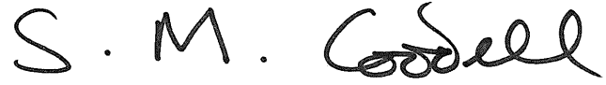

Sharon Caddell
Chief Executive to the Police and Crime Commissioner for Nottinghamshire

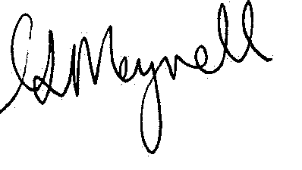
Kate Meynell
Chief Constable of Nottinghamshire Police

Members of the Joint Independent Audit Committee

Stephen Charnock (Chair)
Leslie Ayoola
Peter McKay
Alan Franks
Lisa Dawkins

Notes:

1. Meetings of the Joint Independent Audit Committee are open to the press and public and all are welcome to attend at the time and address indicated on the front of this agenda. If you would like further information please contact Emma Lau, JHQ, Sherwood Lodge, Arnold, Notts, NG5 8PP, officepcc@notts.police.uk and 0115 844 5998

- Items have not been circulated to the press and public on the grounds that it contains restricted information as defined under the Government Protective Marking Scheme (GPMS).

